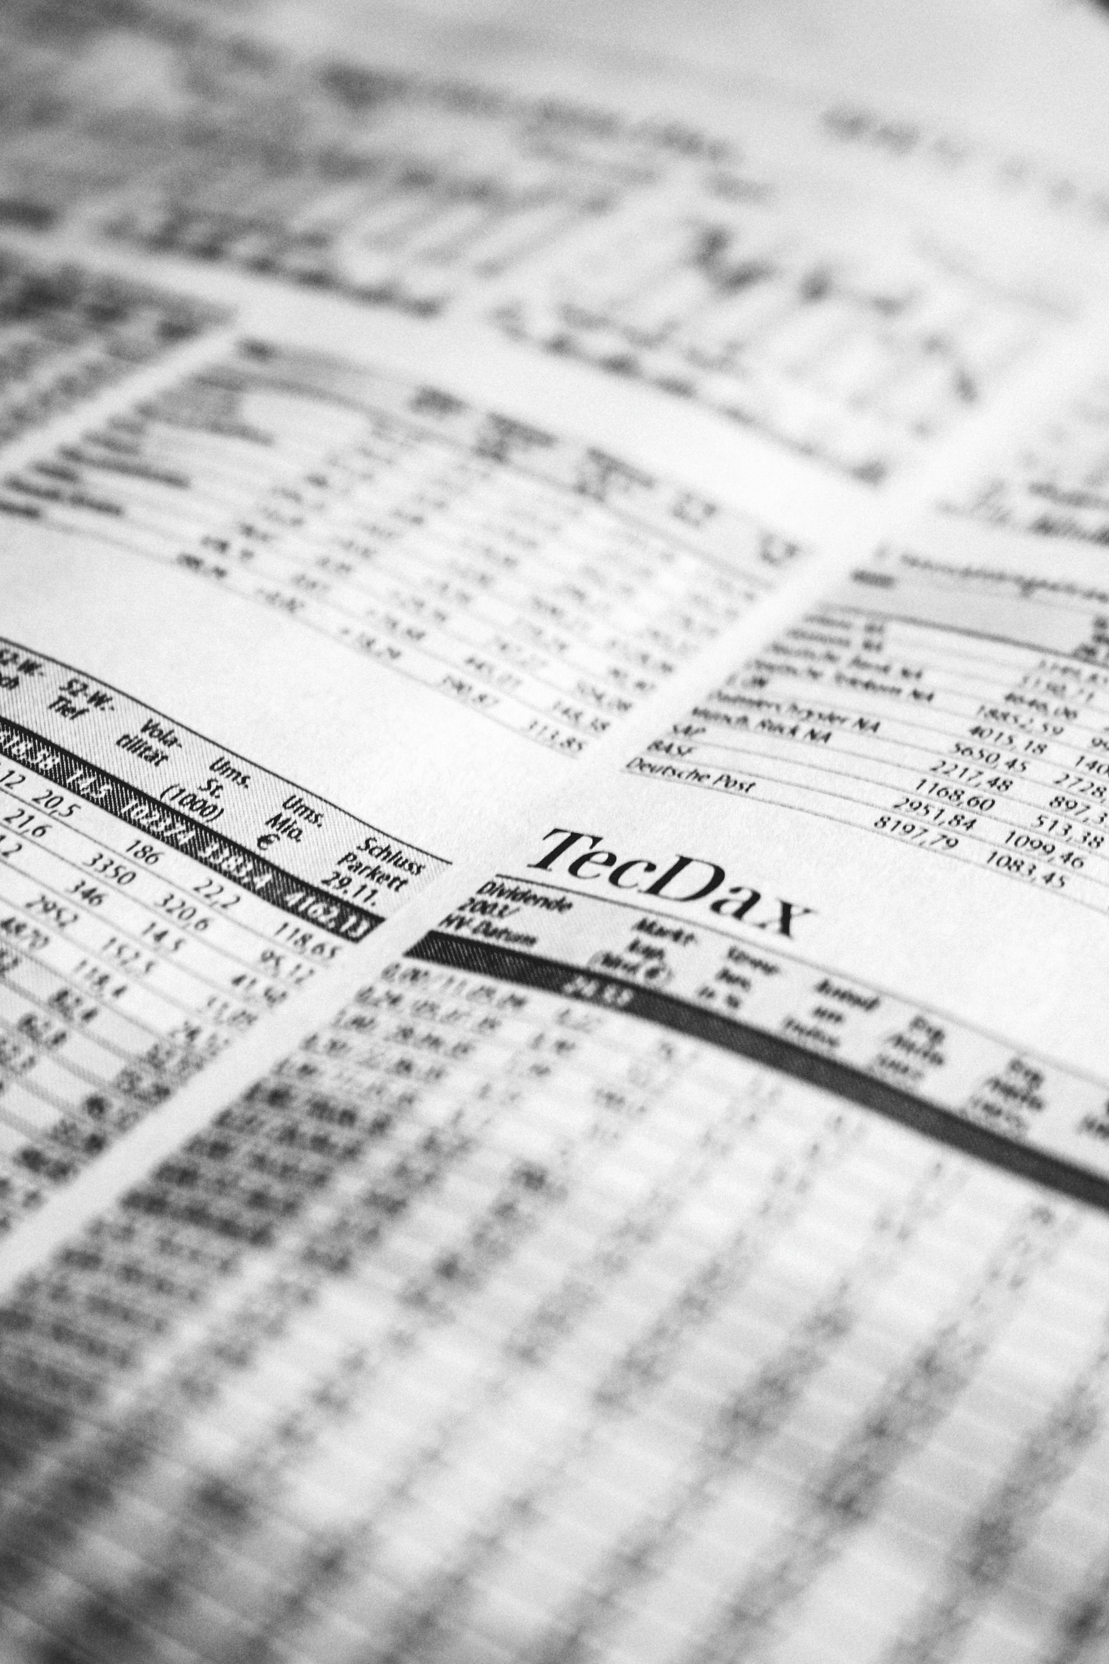

|  |
| --- |
| Financial Analysis  2019 to 2023  Companies:  *Ansari Sugar Mills Limited*  *Colony Textile Mills Limited*  *Nishat Chunian Limited*  *Pak Suzuki Motor Company Limited*  Presented By:  Owais Mukhtar  To:  Mian Atif |

Contents

Pak Suzuki Motor Company Limited 3

Introduction 3

Analysis 4

Liquidity Ratios 4

Profitability 4

Solvency Ratios 4

Times Interest Earned: 4

Efficiency and Market Ratios 4

Horizontal analysis 4

Recommendation 4

For Investor: 4

For Firm: 4

Conclusion 4

Colony Textile Mills Limited 4

Introduction 4

Analysis 4

Liquidity Ratios 4

Profitability Ratios 4

Solvency Ratios 4

Efficiency and Market Ratios 4

Horizontal 4

Vertical 4

Recommendation 4

For Investor: 4

For company: 4

Conclusion 4

Nishat Chunian Limited 4

Introduction 4

Analysis 4

Liquidity Ratios 4

Profitability Ratios 4

Solvency Ratios 4

Efficiency and Market Ratios 4

Horizontal Analysis 4

Vertical Analysis 4

Recommendation 4

For Investor 4

For Company 4

Conclusion 4

Ansari Sugar Mills Limited 4

Introduction 4

Analysis 4

Liquidity Ratios 4

Profitability Ratios 4

Solvency Ratios 4

Efficiency and Market Ratios 4

Recommendation 4

for Investors: 4

for Ansar Sugar Mill (Company): 4

Conclusion: 4

Which is Best for Investment: 4

Ansar Sugar Mill 4

Colony 4

Suzuki 4

Nishat 4

Conclusion: 4

# Pak Suzuki Motor Company Limited

## **Introduction**

Pak Suzuki Motor Company Limited, a renowned public limited company established in 1983, is a pioneering joint venture between Pakistan Automobile Corporation Limited and Suzuki Motor Corporation, Japan. Under the visionary leadership of CEO Hiroshi Kawamura and Chairperson Kinji Saito, supported by Company Secretary Abdul Nasir, Pak Suzuki has emerged as a leading player in Pakistan's automotive industry.

With a rich legacy of over three decades, Pak Suzuki is dedicated to delivering exceptional quality Suzuki vehicles, including cars, pickups, vans, 4x4s, motorcycles, and genuine spare parts, catering to the diverse needs of Pakistani customers.

## **Analysis**

### Liquidity Ratios

#### Current Ratios:

The decline in Pak Suzuki's Current Ratio from 1.14 in 2019 to 1.03 in 2023 indicates a slight deterioration in its short-term liquidity position. This ratio measures a company's ability to pay its short-term debts using its short-term assets. Company has loss potential to pay 1 Rupee liability from 1.14 to 1.03.

Key Observations:

1. Reduced liquidity: The decreasing Current Ratio suggests that Pak Suzuki's ability to meet its short-term obligations has slightly weakened.
2. Increased dependence on debt: The company may be relying more on debt financing, which can increase its financial risk.
3. In 2023, Stock in Trade is the largest portion of Current Assets at 34.9 million, and Trade & Others Payable dominates Current Liabilities at 60.1 million.
4. The decline in the Current Ratio to 1.03 suggests that increasing liabilities, particularly in Trade and Others Payable, are growing faster than the growth in Current Assets.

#### Quick Ratio:

The Quick Ratio fluctuated between 0.40 and 0.69 from 2019 to 2023. The low Quick Ratio values suggest that the company relies significantly on inventory for meeting short-term obligations.

Key Observation:

* Low Quick Ratio: 0.43 in 2023, indicating significant reliance on inventory to meet short-term obligations.
* Decreased Cash & Bank Balance: Substantial decline from 49.6 million in 2022 to 6.3 million in 2023, weakening immediate liquidity.
* High Inventory Dependence: Excluding Stock in Trade (34.9 million), remaining Quick Assets are significantly lower than Current Liabilities.
* Reduced Liquidity: Drop in Quick Ratio reflects decreased cash availability and higher reliance on non-liquid assets.

Implications:

* Liquidity Risk: Pak Suzuki's ability to meet short-term obligations is compromised due to low cash reserves.
* Inventory Management: High inventory levels may indicate inefficient inventory management or slow sales.
* Increased Financial Risk: Reduced cash availability and high inventory dependence increase financial risk.
* Limited Flexibility: Low Quick Ratio limits Pak Suzuki's ability to respond to unexpected expenses or revenue shortfalls.

#### Cash Ratio:

The Cash Ratio showed variability, peaking at 0.57 in 2022, but declining to 0.09 in 2023. This indicates a sharp drop in cash reserves relative to liabilities, which is critical for assessing immediate liquidity.

Key Observation:

* Cash Reserves Plummet: 87% decline in Cash & Bank Balance from 49.6 million in 2022 to 6.3 million in 2023.
* Low Cash Ratio: 0.09 in 2023, indicating limited cash availability for immediate obligations.
* High Trade & Others Payable: 60.1 million in 2023, exacerbating liquidity concerns.

Liquidity Alert:

* Insufficient Cash: Limited funds to meet short-term obligations.
* Supplier Pressure: High Trade & Others Payable may lead to supplier concerns and potential disruptions.
* Cash Flow Management: Urgent need to improve cash flow generation

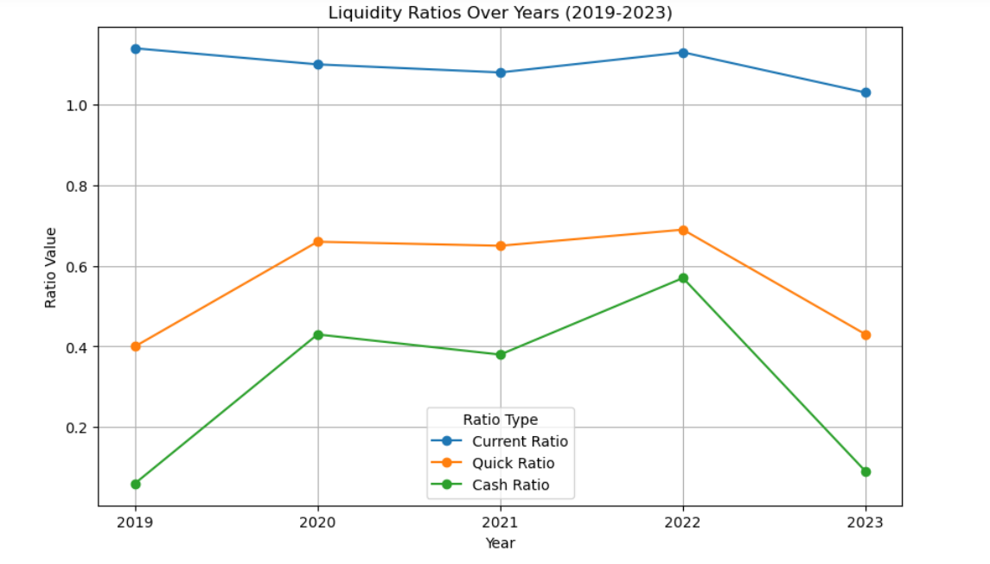Pak Suzuki Motor Company Limited faces significant liquidity challenges due to low cash reserves and high payable amounts. Its weak liquidity position poses financial risks and potential supplier disruptions. Urgent attention is required to improve cash flow management and mitigate these risks.

### Profitability

#### Gross Profit Margin:

Gross Profit Margin (GPM): 16.92% (up from 1.70% in 2019). This improvement indicates better pricing strategies or cost controls, which significantly boosted profitability at the gross level in 2023.

Key Observation:

* Improved Profitability: The significant increase in GPM from 1.70% in 2019 to 16.92% in 2023 indicates substantial improvement in profitability.
* Better Pricing Strategies: Higher GPM may be due to effective pricing strategies, enabling Pak Suzuki to maintain or increase prices despite market conditions.
* Cost Controls: Efficient cost management and reduction in direct costs (e.g., material, labor) contributed to the increased GPM.

Implication:

* Competitive Advantage: Pak Suzuki's improved GPM positions the company favorably against competitors.
* Increased Flexibility: Higher profitability provides flexibility to invest in growth initiatives, reduce debt, or return value to shareholders.
* Sustainability: Maintaining or improving GPM is crucial for long-term sustainability and growth.

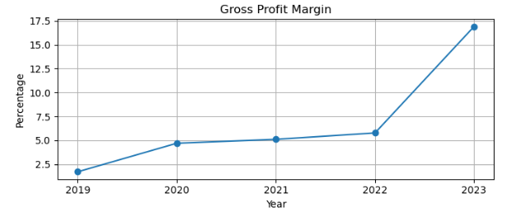

#### Operating Profit Margin:

Operating Profit Margin increased from -2.47% in 2019 to 10.67% in 2023, reflecting improved efficiency in managing operating expenses.

Kay Observation:

* Improved Efficiency: Significant increase indicates enhanced operating efficiency.
* Effective Cost Control: There has been a positive trend in managing our administrative and selling expenses in relation to our revenue growth. In 2023, we successfully achieved a 22% reduction in selling expenses, while our administration costs remained stable. Additionally, we noted a slight 20% decline in administration expenses in 2022. This shows our commitment to enhancing efficiency and optimizing our expenditures.
* Operational Turnaround: Transition from negative in 2019 to positive in 2023 demonstrates substantial progress.

Implication:

* Sustainability: Improved OPM enhances Pak Suzuki's long-term sustainability.
* Competitiveness: Increased operational efficiency positions the company favorably against competitors.
* Investment Potential: Higher profitability attracts investors and supports growth initiatives.

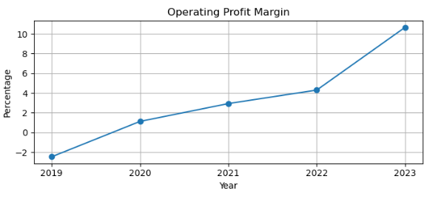

#### Net Profit Margin:

The Net Profit Margin worsened in 2023, declining to **-12.40%** due to high finance costs and deferred taxation.

Key Observation:

* Pak Suzuki's NPM worsened to -12.40% in 2023. This indicates a significant decline in net profitability. The decline was primarily driven by high finance costs and deferred taxation expenses. This raises concerns about the company's financial sustainability.
* Deferred Taxation: Deferred taxation provision surged 216% in 2023. Changes in tax laws or reassessment of tax liabilities led to this increase. This expense offset operational efficiency gains. Reviewing tax strategies can minimize deferred taxation impact.
* Operational Efficiency: Pak Suzuki achieved operational efficiency with a 10.67% Operating Profit Margin. Improved cost management and sales strategies contributed to this success. However, financial and taxation expenses overshadowed operational gains. Maintaining operational efficiency is crucial.

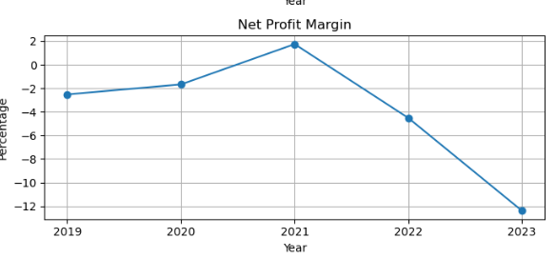

#### Return on Asset:

ROA deteriorated from 3.08% in 2021 to -15.35% in 2023, driven by increasing net losses and shrinking total assets.

Key Observation:

* Deteriorating ROA: Sharp decline from 3.08% in 2021 to -15.35% in 2023.
* Increasing Net Losses: Net losses surged, negatively impacting ROA.
* Shrinking Total Assets: Decrease in total assets reduced asset utilization efficiency. Also increase assets in 2021 and 2022 due to Loan and advance 668%.
* Reduced Efficiency: Assets are not generating profits effectively.

Implication:

* Asset Utilization Concerns: Inefficient use of assets impacts profitability.
* Financial Sustainability Risks: Negative ROA raises concerns about financial sustainability.

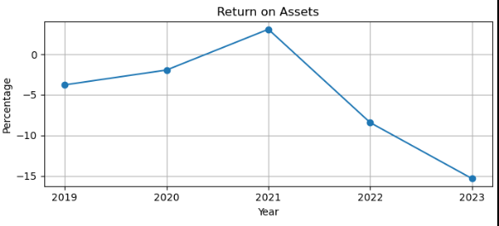

#### Dupont Analysis:

The DuPont Analysis breaks down the Return on Equity (ROE) into three key components: Net Profit Margin, Asset Turnover Ratio, and Financial Leverage. This decomposition highlights areas driving profitability and reveals hidden insights into the company’s financial performance. Let's explore the hidden points based on your provided data:

Net Profit Margin :

Observation: The declined significantly in 2023 to -12.40%, from positive values in 2021.

Hidden Points:

Finance Costs: These rose sharply in 2023 to 10.96 million, consuming a large portion of operating income. High finance costs are a key driver of negative NPM.

Taxation Impact: Deferred taxation surged to 10.09 million in 2023, further eroding net profitability.

Revenue Volatility: Sales decreased sharply in 2023 (from 202.47 million in 2022 to 102.10 million), limiting profit generation despite operational efficiency.

Asset Turnover Ratio

Observation: Asset Turnover declined to 123.81% in 2023 from a peak of 186.84% in 2022, showing reduced efficiency in utilizing assets to generate revenue.

Underutilized Assets: A decline in revenue despite significant total assets indicates underutilization or inefficiencies in operations.

Working Capital Management: High levels of current assets (e.g., Stock in Trade at 34.9 million in 2023) suggest potential inefficiencies in inventory turnover or accounts receivable collection.

3. Financial Leverage

Observation:

Financial Leverage skyrocketed to 857.58% in 2023, up from 556.81% in 2022, indicating heavy reliance on debt financing.

High Risk Exposure: The company’s equity base is shrinking relative to its liabilities, increasing risk for shareholders and reducing ROE stability.

Debt Dependency: Heavy reliance on borrowed funds to sustain operations can magnify losses during downturns, as evidenced by the negative ROE in 2023.

Interplay Between Components

Observation:

The combined effect of these components led to a negative ROE of -131.63% in 2023.

Amplification of Losses:

Asset Turnover peaked in 2022 at 186.84%, showing excellent asset utilization during that period.

In 2023, it dropped to 123.81%, indicating reduced efficiency, possibly due to:

A decline in sales (102.10M in 2023 vs. 202.47M in 2022).

Excessive current assets like high Stock in Trade (34.9M) and Receivables (16.7M) that are not translating into revenue.

Financial leverage amplifies the impact of a declining Net Profit Margin. While leverage can boost ROE when margins and turnover are positive, in 2023, it magnified losses.

Misaligned Priorities: The company’s efforts to improve operational efficiency (evidenced by improved Gross and Operating Profit Margins) were overshadowed by poor financial management (high finance costs and excessive leverage).

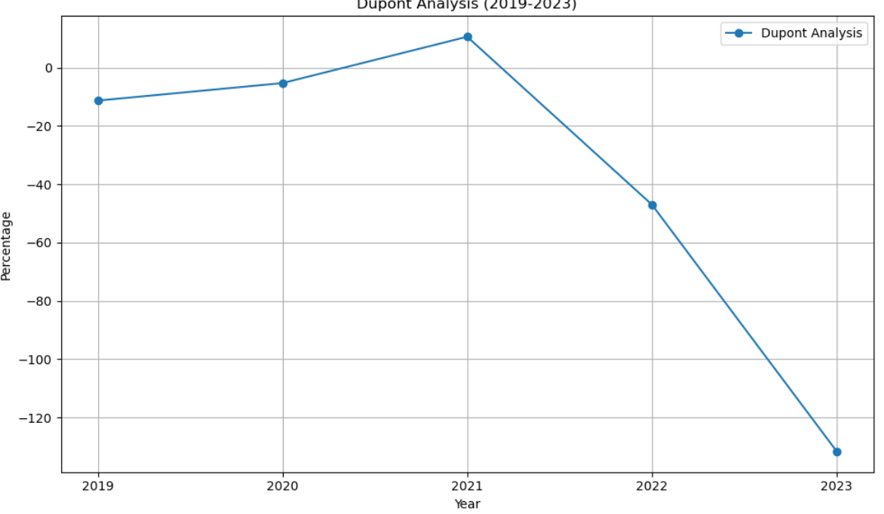

### Solvency Ratios

#### Debt to equity:

This ratio indicates the extent to which a company relies on borrowed funds compared to shareholder equity to finance its operations. A rising ratio signals increasing reliance on debt, which can lead to greater financial risk, especially if equity is simultaneously decreasing.

Key Observation:

* 2019-2020: The absence of long-term debt resulted in a Debt to Equity Ratio of 0, indicating no leverage.
* 2021: The ratio rose to 0.0630 as the company took on 1.69M in borrowings, albeit manageable given the equity level of 26.83M.
* 2022-2023: The ratio climbed further to 0.0892 and 0.1629, driven by declining equity. Equity dropped significantly to 9.82M in 2023, amplifying the impact of stable debt levels.

Implications:

* Leverage Concerns: The rising ratio indicates increasing financial risk due to higher reliance on debt. Declining equity further exacerbates this risk, leaving the company with limited capacity to take on more debt or absorb financial shocks.
* Creditor and Investor Confidence: Higher leverage can deter creditors and investors, as it signals a potential inability to repay obligations or fund future growth.

### Times Interest Earned:

Key Observation:

* 2019-2020: The TIE was stable at 1, indicating the company barely covered its interest obligations.
* 2021: A dramatic improvement to 6.00 resulted from increased EBIT and significantly lower finance costs (0.74M).
* 2022-2023: The TIE ratio declined sharply:
* In 2022, high finance costs (11.61M) consumed almost all EBIT.
* In 2023, EBIT turned negative (-10.96M), rendering the company unable to cover interest expenses (TIE = 0).

Implication:

* Interest Coverage Risk: The TIE below 1 in 2023 signifies that the company is in financial distress, unable to meet interest obligations, increasing the risk of default.
* Operational Concerns: A negative EBIT in 2023 reflects deteriorating operational efficiency, which directly impacts the company's ability to service debt.

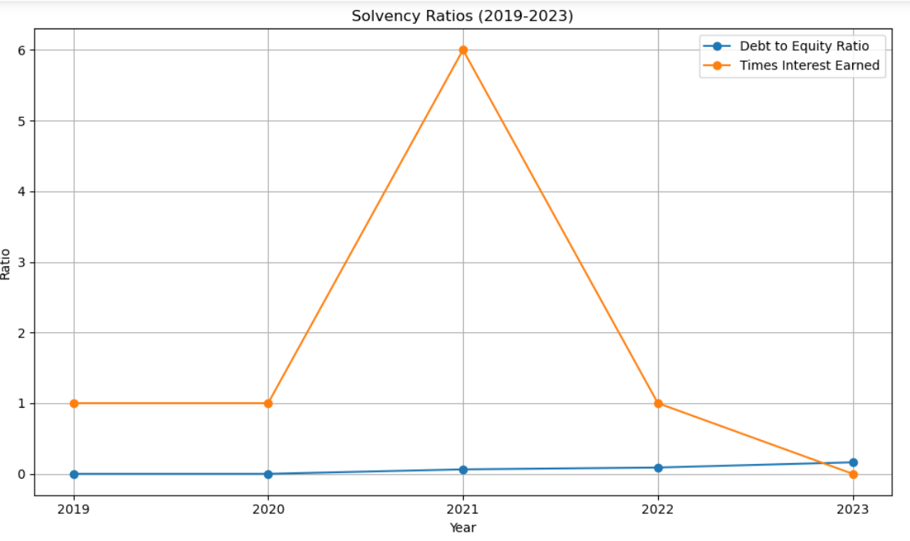

### Efficiency and Market Ratios

#### Inventory Turnover Ratio:

Key Observation:

The Inventory Turnover Ratio reflects fluctuating efficiency in managing and converting inventory into sales over the years:

* 2019: Very low (1), indicating poor inventory management or weak sales.
* 2020-2021: Substantial improvement, peaking at 7 in 2021, showing highly efficient inventory utilization and sales.
* 2022: A slight decline to 6, still reflecting good efficiency.
* 2023: A sharp drop to 2, signaling a significant slowdown in inventory turnover, possibly due to reduced demand, overstocking, or operational challenges.

Implication:

Financial Performance:

2019 and 2023 suggest inefficiency, tying up capital in unsold inventory, increasing holding costs, and risking obsolescence. This can lead to reduced liquidity and strained cash flow.

Improved turnover in 2020-2022 positively impacts profitability and cash flow, reflecting better alignment between inventory levels and demand.

Operational Efficiency:

2019 and 2023 highlight potential issues such as overproduction, poor demand forecasting, or ineffective sales strategies.

2020-2022 demonstrate optimized inventory practices and stronger operational controls.

Market Responsiveness:

The decline in 2023 may indicate an inability to adapt to changing market conditions, leading to excess inventory or slower sales.

#### Operating Ratio:

Key Observation:

* Across **2019–2023**, the ratio remained constant at **2**, suggesting that operational costs consistently exceeded net sales. This indicates a lack of efficiency in controlling expenses relative to revenue generation.

Implication:

A high operating ratio suggests slim margins and limited capacity to handle economic downturns or cost increases.

#### Day sales outstanding:

Observation:

* 2019: High collection, tying up significant cash in receivables.
* 2020-2022: Reduced to 6, 2, and 1 day, indicating a dramatic improvement in receivables collection efficiency.
* 2023: 6 days – Slight increase, signaling potential delays in collections compared to earlier years.

Implication:

Day sale Outstanding is still manageable, the upward trend in 2023 could signal early inefficiencies, requiring attention to maintain liquidity.

#### Price-to-Earnings (P/E) Ratio:

Key Observation:

The significant fluctuations in the Price-to-Earnings (P/E) Ratio over the years, especially the negative ratios in 2019, 2020, 2022, and 2023, and the spike in 2021, can be attributed to a combination of factors related to the company's earnings, market performance, and investor sentiment.

Implication:

Negative Earnings (Net Losses): A negative P/E ratio typically occurs when a company posts a net loss instead of a profit. In these years, the company likely faced significant financial challenges, including:

Declining sales or revenues: The company may have struggled to generate sufficient revenue or experienced declining market demand, leading to losses.

High operating or financial costs: Increased finance costs (e.g., high finance costs and taxes) could have eroded profitability, contributing to negative earnings.

Increased debt and interest burden: The Times Interest Earned ratio was low, suggesting the company struggled to meet its interest obligations, leading to financial stress.

Negative Profit Margins: Both Net Profit Margin and Return on Equity (ROE) were negative, signaling that the company was not generating profits efficiently relative to its sales or equity.

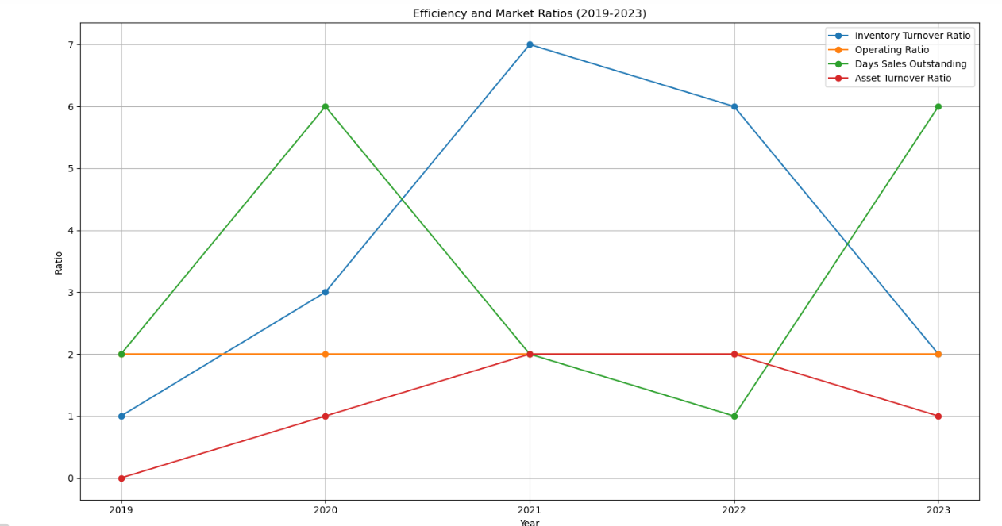

### Horizontal analysis

|  |  |  |  |  |  |  |  |
| --- | --- | --- | --- | --- | --- | --- | --- |
| Horizontal Analysis | *Balance Sheet* | Share Capital | 0% | 0% | 0% | 0% | 0% |
|  |  | Capital & Other Reserves | 0% | 0% | 0% | 0% | 0% |
|  |  | Revenue Reserves | 0% | -7% | 11% | -28% | -55% |
|  |  | Surplus on Revaluation of Fixed Assets | 0% | #DIV/0! | #### | #### | ##### |
|  |  | Long-term Borrowing | 0% | #DIV/0! | #### | 4% | -9% |
|  |  | Long-Term Lease Liabilities | 0% | -16% | -9% | 10% | -12% |
|  |  | Others | 0% | 65% | #### | 15% | -18% |
|  |  | Trade & Others Payable | 0% | 54% | #### | 4% | -6% |
|  |  | Interest & Markup | 0% | #DIV/0! | #### | #### | ##### |
|  |  | Short Term Borrowing | 0% | -61% | #### | #### | -100% |
|  |  | Current Portion Of Long Term Liabilities | 0% | #DIV/0! | #### | #### | 83% |
|  |  | Current Taxation | 0% | #DIV/0! | #### | #### | -2% |
|  |  | PPE | 0% | -17% | 19% | -4% | 37% |
|  |  | Investment Property | 0% | #DIV/0! | #### | #### | ##### |
|  |  | Long Term Investments | 0% | -15% | #### | -56% | -100% |
|  |  | Long Term Loans and Advances | 0% | 47% | 8% | 35% | 51% |
|  |  | Long Term Deposits | 0% | 67% | 22% | 83% | -26% |
|  |  | Deferred Tax | 0% | 170% | 15% | 0% | -100% |
|  |  | Others | 0% | 0% | 49% | -15% | -30% |
|  |  | Store Spares & Loose Tools | 0% | -3% | 45% | 33% | 170% |
|  |  | Stock In Trade | 0% | -52% | 46% | 26% | 6% |
|  |  | Trade Debts | 0% | -27% | #### | 95% | 255% |
|  |  | Loans & Advances | 0% | 116% | 37% | #### | 41% |
|  |  | Other Receivables | 0% | -44% | 88% | -94% | 1667% |
|  |  | Short Term Investments | 0% | -100% | #### | #### | ##### |
|  |  | Cash & Bank Balance | 0% | 445% | 31% | #### | -87% |
|  | *Income Statement* | Sales | 0% | -34% | #### | 26% | -50% |
|  |  | Cost of Sales | 0% | -36% | #### | 26% | -56% |
|  |  | Administrative Expenses | 0% | -30% | 39% | 19% | 32% |
|  |  | Selling Cost & Distribution Cost | 0% | -35% | 79% | 9% | -22% |
|  |  | Other Operating Income | 0% | 217% | #### | 45% | -33% |
|  |  | Other Operating Expenses | 0% | -4410% | #### | -97% | ##### |
|  |  | Finance Cost | 0% | 28% | #### | #### | -6% |
|  |  | Provision For Taxation: Deferred | 0% | -19% | #### | #### | 216% |
|  |  | Provision For Taxation: Current | 0% | 1145% | 74% | 52% | -14% |

#### Vertical Analysis

|  |  |  |  |  |  |  |  |
| --- | --- | --- | --- | --- | --- | --- | --- |
| Vertical Analysis | *Balance Sheet* | Share Capital | 1.06% | 1.23% | 0.89% | 0.75% | 0.98% |
|  |  | Capital & Other Reserves | 1.09% | 1.27% | 0.92% | 0.77% | 1.00% |
|  |  | Revenue Reserves | 31.27% | 33.95% | 27.35% | 16.44% | 9.68% |
|  |  | Surplus on Revaluation of Fixed Assets | 0.00% | 0.00% | 0.00% | 0.00% | 0.00% |
|  |  | Long-term Borrowing | 0.00% | 0.00% | 1.84% | 1.60% | 1.90% |
|  |  | Others | 0.15% | 0.15% | 0.10% | 0.09% | 0.10% |
|  |  | Trade & Others Payable | 0.51% | 0.99% | 1.68% | 1.61% | 1.73% |
|  |  | Interest & Markup | 24.19% | 43.48% | 67.17% | 58.27% | 71.42% |
|  |  | Short Term Borrowing | 0.00% | 0.00% | 0.00% | 0.00% | 0.00% |
|  |  | Current Portion Of Long Term Liabilities | 41.73% | 18.94% | 0.00% | 10.28% | 0.00% |
|  |  | PPE | 0.00% | 0.00% | 0.05% | 0.10% | 0.25% |
|  |  | Long Term Loans and Advances | 0.00% | 0.00% | 0.00% | 10.07% | 12.94% |
|  |  | Long Term Deposits | 20.20% | 19.56% | 16.90% | 13.51% | 24.17% |
|  |  | Store Spares & Loose Tools | 0.00% | 0.00% | 0.00% | 0.00% | 0.00% |
|  |  | Stock In Trade | 0.42% | 0.42% | 0.21% | 0.08% | 0.00% |
|  |  | Trade Debts | 0.00% | 0.01% | 0.01% | 0.01% | 0.01% |
|  |  | Loans & Advances | 0.36% | 0.70% | 0.62% | 0.94% | 0.91% |
|  |  | Other Receivables | 3.04% | 9.55% | 7.98% | 6.67% | 0.00% |
|  |  | Cash & Bank Balance | 1.11% | 1.29% | 1.38% | 0.98% | 0.90% |
|  | *Income Statement* | Sales | 100.00% | 100.00% | 100.00% | 100.00% | 100.00% |
|  |  | Cost of Sales | 98.30% | 95.31% | 94.90% | 94.23% | 83.08% |
|  |  | Administrative Expenses | 2.19% | 2.33% | 1.55% | 1.46% | 3.81% |
|  |  | Selling Cost & Distribution Cost | 2.18% | 2.14% | 1.84% | 1.59% | 2.46% |
|  |  | Other Operating Income | 0.19% | 0.92% | 1.39% | 1.59% | 2.09% |
|  |  | Other Operating Expenses | 0.00% | 0.02% | 0.17% | 0.00% | 2.07% |
|  |  | Finance Cost | 1.79% | 3.47% | 0.46% | 5.74% | 10.74% |
|  |  | Provision For Taxation: Current | -1.83% | -2.24% | -0.61% | 1.58% | 9.89% |

## **Recommendation**

### For Investor:

Due to its uneven performance in important areas, investors should proceed cautiously when dealing with this firm. A negative net profit margin, declining liquidity, and a steep drop in the inventory turnover ratio in 2023 all point to possible cash flow issues and operational inefficiencies. The company's financial viability is further called into question by the growing debt-to-equity ratio and the incapacity to pay operational expenses with operating revenues. Before making large financial commitments, investors are encouraged to use a "wait-and-see" strategy, attentively observing gains in inventory control, profitability, and debt management.

### For Firm:

The company must prioritize operational and financial stability to regain investor confidence. Enhancing inventory management through better demand forecasting and just-in-time practices can prevent overstocking and improve turnover. Strengthening liquidity and reducing financial leverage are essential for addressing immediate cash flow concerns and improving solvency ratios. Additionally, optimizing operating expenses, diversifying revenue streams, and leveraging technology to streamline processes will contribute to sustained profitability. Clear communication of these strategic improvements can attract investors and position the company for long-term growth.

## **Conclusion**

In other years, persistent financial difficulties are reflected in negative P/E ratios, when losses exceeded earnings and the firm became unappealing to investors. Nonetheless, the 2021 P/E ratio rise suggests a brief time of market optimism or profitability, which may have been fueled by advantageous financial or operational developments. However, this kind of volatility makes it hard to forecast long-term stability and profitability, which may add to market apprehension about the company's prospects.

# Colony Textile Mills Limited

## **Introduction**

Colony Textile Mills Limited (CTM) is a pioneering textile manufacturer in Pakistan, established in 1946 and re-established in 2011. Led by CEO Fareed Mughis Sheikh, Chairperson Muhammad Atta Ullah Khan, and Company Secretary Muhammad Abid, CTM produces superior quality yarns, fabrics, garments, and made-ups, with a presence in real estate trading. As a Public Company Limited by shares under The Companies Act 2017, CTM boasts a rich history of research, innovation, and quality excellence, driven by transparency, product innovation, and financial strength to create value for stakeholders while maintaining competitiveness in the core business.

## **Analysis**

### Liquidity Ratios

#### Current Ratio:

Declined from ****1.51**** in 2019 to ****1.16**** in 2023.

Key Observation:

* Disproportionate growth in current assets vs. current liabilities. Although current assets have increased in certain periods, the growth is not proportional to the increase in current liabilities. For example, inventories (largest component of current assets) remained stable, but trade debts and loans fluctuated, indicating inconsistent cash inflows.
* Stable inventories, but fluctuating trade debts and loans.
* Significant increase in trade payables and short-term borrowings.

The company’s aggressive growth strategy or inability to generate sufficient cash flow could be causing it to take on more short-term liabilities, weakening its liquidity position.

Implication:

* Weakened Liquidity Position: Increased reliance on external credit may lead to liquidity crises.
* Cash Flow Management Issues: Inability to generate sufficient cash flow to support operations.
* Risk of Debt Accumulation: Growing short-term liabilities may lead to debt accumulation and increased financial risk.
* Sustainability Concerns: Aggressive growth strategy may compromise long-term sustainability.
* Potential Impact on Credit Rating: Increased debt and weakened liquidity may negatively affect credit rating.

#### Quick Ratio

Relatively stable, fluctuating between 0.51 and 0.61 over the years.

Key Observation:

* Inventories’ Dominance: Inventories constitute a significant proportion of current assets, and their consistent levels keep the ratio stable. However, other liquid assets like trade debts and cash have not grown sufficiently to improve the ratio.
* Hidden Cash Constraints: The low cash balance reflects poor liquidity despite the ratio’s stability, as it excludes inventory from the calculation.

Implication:.

* Inventory levels, while consistent, have not translated into higher liquidity. This might indicate slow-moving inventory or overstocking, tying up funds that could have been used elsewhere.
* Excluding inventory, the company lacks sufficient liquid assets to cover its current liabilities fully.

#### Cash Ratio

Consistently low at 0.01, with a brief dip to 0.00.

Key Observation:

* Cash reserves are alarmingly low, suggesting inefficient cash management. This might be due to high operational expenses, debt repayments, or excessive investments in inventories and receivables.
* The high reliance on short-term borrowings further drains cash resources for interest and principal repayments.

Implication:

* The near-zero cash ratio is a red flag indicating a potential liquidity crisis. The company may face challenges meeting immediate obligations if it cannot secure additional financing.
* Despite having receivables and inventory, the company’s inability to convert these into cash limits its ability to meet short-term obligations.
* The Cash Ratio has consistently been at 0.01, except for one period where it dropped to 0.00. This indicates that the company has minimal cash reserves relative to its liabilities and is overly dependent on less liquid assets like receivables and inventories.

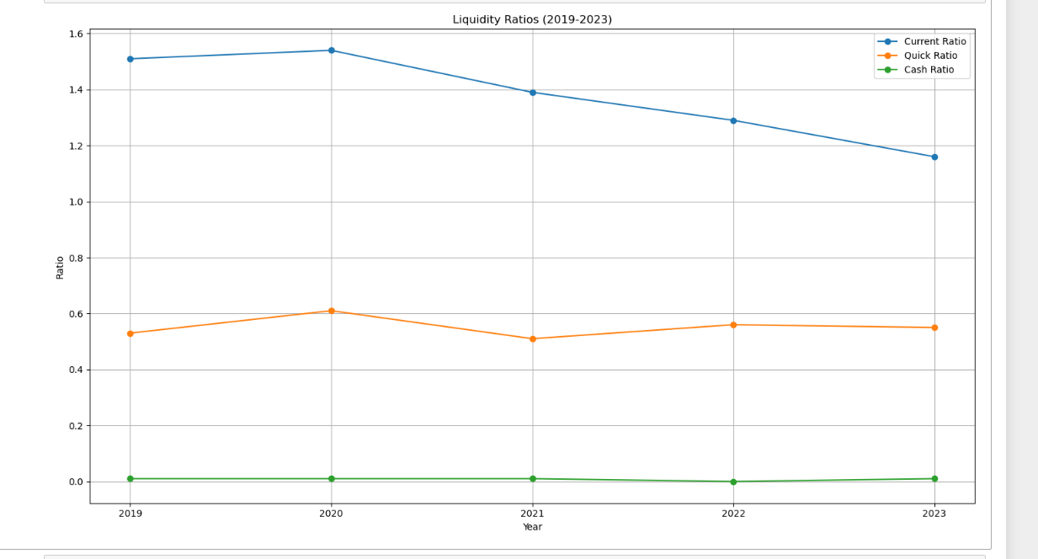

### Profitability Ratios

#### Gross Profit Margin:

Decreased from 7.47% in 2019 to -3.72% in 2023

Key Observation:

* Net sales dropped from 23,123,399 in 2019 to 20,852,724 in 2023 (-9.8%).
* Cost of sales increased disproportionately, rising by 10.9% in the same period, leading to the gross loss in 2023.
* Rising costs without proportional revenue growth diminished gross profitability. The equity increase could not counterbalance the operational inefficiencies.

Implication:

* Operational Inefficiencies: Inability to control costs erodes profitability.
* Pricing Power Erosion: Unable to pass increased costs to customers
* Reduced Competitiveness: Shrinking GPM compromises market position.
* Pressure on Net Income: Insufficient earnings to cover operational expenses.
* Long-term Sustainability Risks: Compromised profitability threatens business viability.

#### Operating Profit Margin:

Fell from **11.81%** in 2019 to **4.51%** in 2020, recovering to **6.93%** in 2023.

Key Observation:

* Operating income was volatile due to fluctuating other operating income (2,134,109 in 2019, then dropping to 93,018 in 2022 before rebounding in 2023).
* Administrative and selling expenses rose by 42.6% from 2019 to 2023, reducing operating profitability.
* Despite rising equity, inefficiencies in managing operational costs and unstable income sources hampered performance.

Implication:

* Financial Sustainability Risks: Unstable income sources threaten long-term viability.
* Inefficient Resource Allocation: Rising administrative and selling expenses erode profitability.
* Limited Growth Potential: Volatile operating income constrains investment and expansion.

#### Net Profit Margin:

Peaked at ****5.68%**** in 2019, turned negative in 2020 (-2.07%), and recovered to ****2.41%**** in 2023.

Key Observation:

* Finance costs surged by 106.5% from 506,075 in 2019 to 1,045,548 in 2023, eroding net profitability.
* Tax provisions showed inconsistent trends, with a reversal in 2023 impacting net results positively.
* Rising finance costs linked to increased debt hindered profitability, even as equity grew modestly.

The fluctuations in net profit margins are primarily driven by inconsistent sales, rising cost of sales, and high finance costs, which the company has struggled to control.

Implication:

* Debt Optimization: Review and restructure debt to reduce finance costs
* Capital Structure Review: Assess and adjust debt-to-equity ratio
* Cost Reduction Strategies: Identify and minimize interest-bearing debt
* Tax Planning: Regularly review and optimize tax strategies
* Financial Discipline: Enhance financial management and monitoring

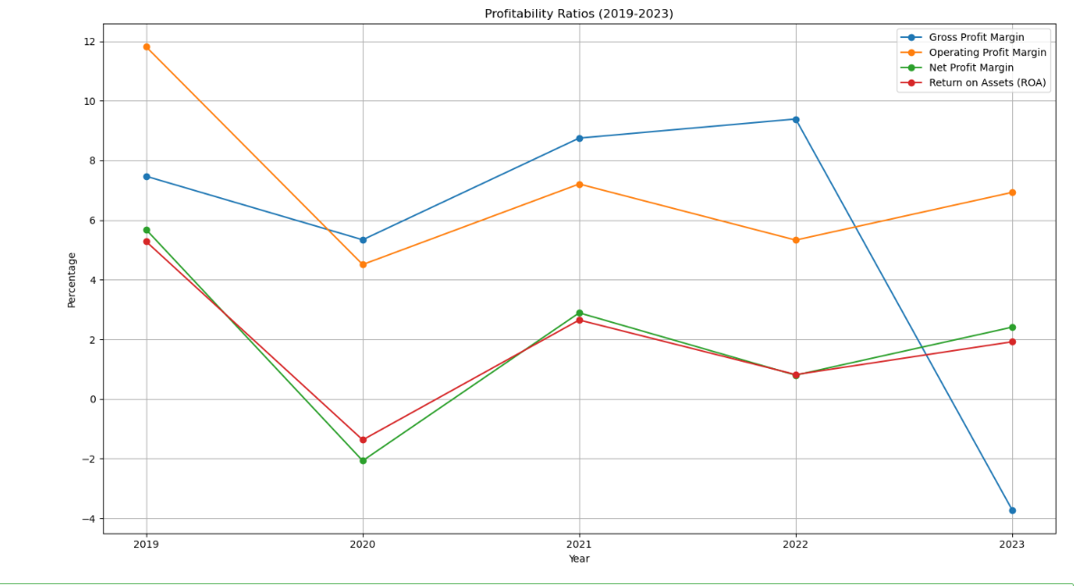

#### Dupont Analysis:

The Dupont analysis breaks down the Return on Equity (ROE) into three components: Net Profit Margin, Asset Turnover, and Financial Leverage. It provides deeper insights into the drivers of ROE and highlights where performance improvements or inefficiencies exist.

Asset Turnover:

Indicates the efficiency of asset utilization to generate revenue.

* 2019: 92.95%
* Strong asset utilization reflects efficient operational capacity. Revenue generation was strong compared to the average asset base.
* 2020: 66.12% Decline in asset turnover was due to decreased net sales (-23.4%) while the asset base remained stable. This highlights inefficiency in using resources to drive sales.
* 2021: 91.75% A rebound driven by increased sales and stable asset levels, indicating improved utilization of resources.
* 2022: 102.69% Asset utilization peaked as sales grew, but higher costs limited profitability.
* 2023: 79.86%Decline in sales relative to the asset base caused a drop in turnover, signaling reduced operational efficiency.

Asset utilization has fluctuated in line with sales trends. Consistency in operational performance is needed to maintain steady turnover rates.

Financial Leverage:

• **2019**: **278.85%** Moderate leverage levels allowed for a balance between risk and return.

• **2020**: **291.55%** Slightly increased leverage, reflecting higher reliance on debt financing amidst declining profitability.

• **2021**: **285.96%**  
Leverage remained stable as equity levels improved and long-term borrowing was limited.

• **2022**: **296.51%** Rising leverage indicated increasing reliance on debt due to operational inefficiencies and rising finance costs.

• **2023**: **270.85%**Reduced leverage as equity increased and the asset base stabilized, though profitability remained under pressure.

Rising financial leverage in certain years increased risk exposure without proportionate returns, showing the need for better debt management and equity utilization.

**Overall Analysis:**

• **2019 (14.7%)**: Strong ROE driven by a combination of positive margins, efficient asset utilization, and moderate leverage.

• **2020 (-4.0%)**: Negative ROE due to negative margins from falling sales and rising finance costs, despite stable turnover and leverage.

• **2021 (7.6%)**: Recovery in ROE driven by improved margins and asset turnover, though leverage remained consistent.

• **2022 (2.4%)**: Weak ROE as profitability struggled due to rising costs, despite strong asset turnover.

• **2023 (5.2%)**: Slight recovery in ROE driven by improved margins and reduced leverage, though weaker turnover limited further gains.

ROE fluctuated significantly due to varying profitability, asset utilization, and leverage. While improvements in margins and reduced leverage aided recovery in 2021 and 2023, inconsistent turnover and rising costs limited sustainable growth.

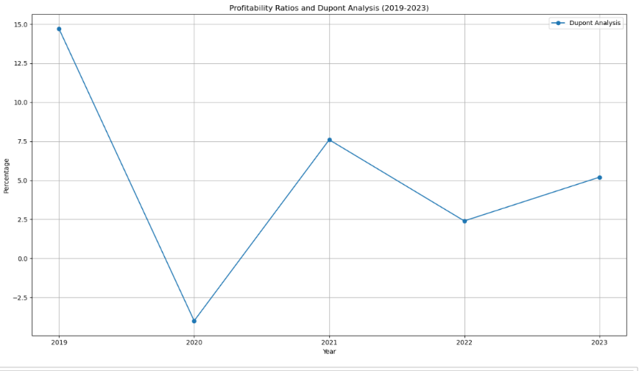

### Solvency Ratios

#### Debt to Equity Ratio:

Key Observation:

* The debt-to-equity ratio shows a decreasing trend from 0.7872 in 2019 to 0.6012 in 2023, indicating a reduction in reliance on long-term debt relative to equity. This suggests a deliberate effort to improve financial stability and lower financial risk over the years.
* The consistent decline in the debt-to-equity ratio reflects management's focus on reducing long-term liabilities, likely to counterbalance the impact of volatile EBIT and maintain solvency.

#### Times Interest Earned

The TIE ratio fluctuated significantly, starting at a robust 4 in 2019, dropping to 1 in 2020-2021, then hitting 0 in 2022 before recovering to 3 in 2023. This ratio indicates the company's ability to meet its interest obligations:

* 2019: Strong EBIT provided ample coverage for interest payments.
* 2020-2021: Decline in EBIT due to falling profitability reduced interest coverage to minimal levels.
* 2022: A sharp drop to 0 highlights operating losses and insufficient EBIT to cover interest expenses.
* 2023: Partial recovery to 3 reflects improved operational efficiency and cost management.

The TIE ratio's fluctuations reveal challenges in maintaining stable operating income, especially during periods of rising costs and declining revenues. This underscores the importance of efficient cost control and revenue stabilization.

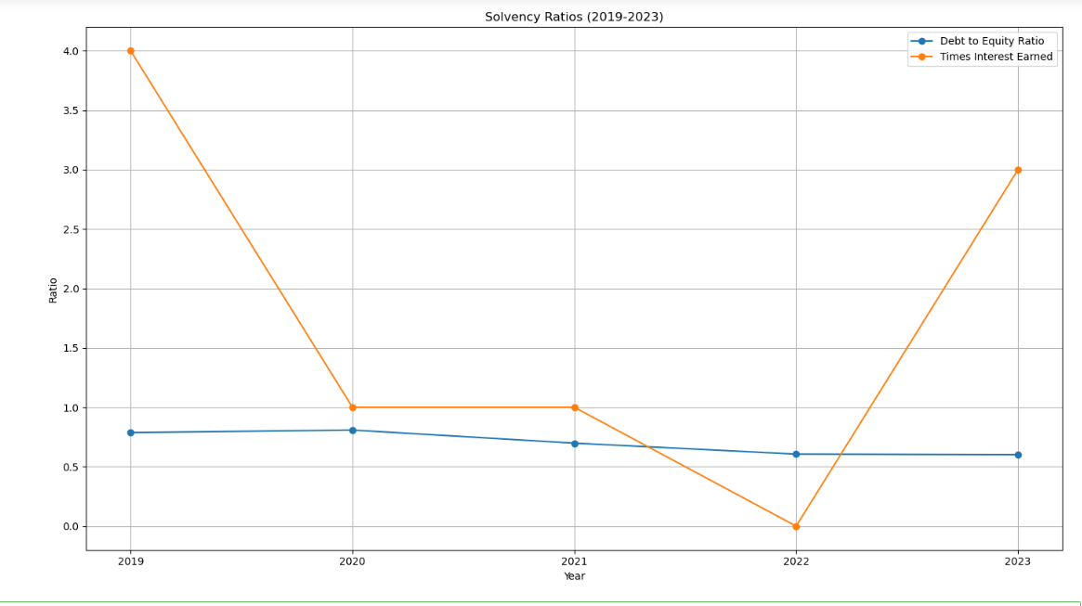

### Efficiency and Market Ratios

#### Inventory Turnover Ratio

Key Observation:

This ratio measures how efficiently the company manages its inventory by determining how many times the inventory is sold and replaced over a year.

* 2019 (0): Indicates poor inventory management or no significant sales activity, leading to inventory stagnation.
* 2020 (4): A sharp improvement reflects better sales activity and inventory utilization.
* 2021-2022 (5-6): Continued efficiency gains show strong inventory management practices.
* 2023 (5): Slight decline suggests a marginal slowdown in inventory movement, potentially tied to external market factors.

Efficient inventory turnover during 2020–2022 indicates streamlined operations. However, the drop in 2023 may hint at slower sales or overstocking.

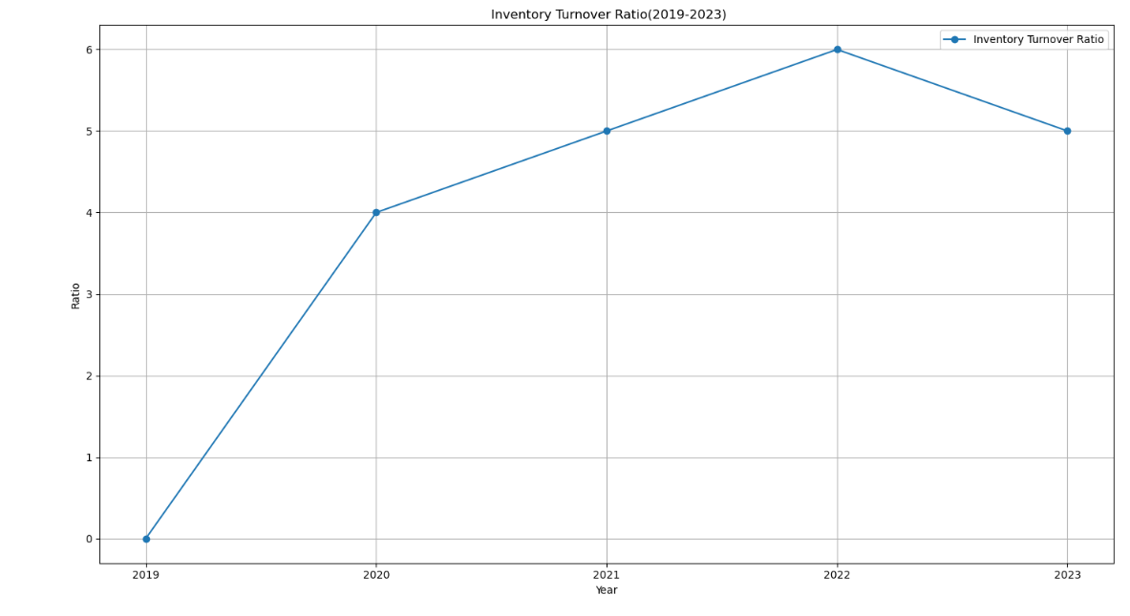

#### Days Sales Outstanding (DSO)

Key Observation:

* 2019 (4008): Extremely high DSO reflects severe inefficiencies in collecting receivables, likely due to lax credit policies or financial constraints of customers. The abysmal DSO and inventory turnover suggest operational bottlenecks, likely from weak demand or ineffective credit and inventory strategies.
* 2020-2022 (47-32): Significant improvement indicates better credit management and timely collections.
* 2023 (45): Slight increase suggests some challenges in receivable collections, though still far better than 2019.

The substantial reduction in DSO from 2019 to 2022 showcases improved credit policies and cash flow management. However, the uptick in 2023 warrants monitoring to prevent liquidity strain.

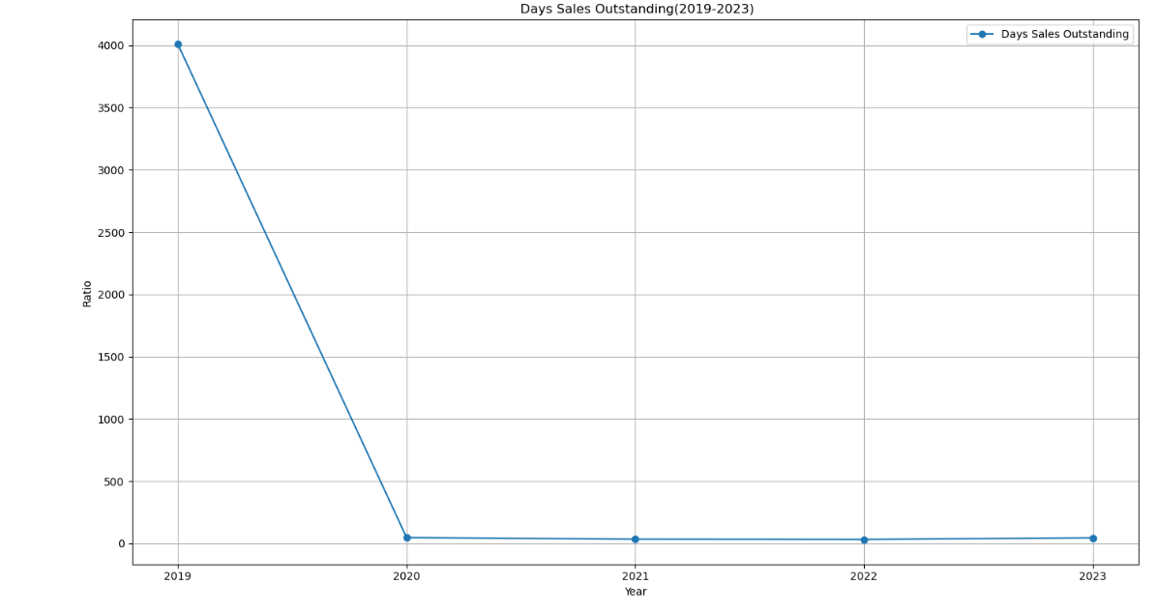

Price-to-Earnings (P/E) Ratio

Key Observation:

The company likely maintained positive earnings in 2019, albeit modest compared to the share price, resulting in a steep ratio. Market overvaluation relative to earnings performance.

* 2020 (-10.2): The negative P/E ratio reflects a net loss, which distorts the calculation. Investors likely became wary of financial performance. The decline indicates poor profitability and weakened market confidence in the company's ability to generate returns. Sharp drop in earnings or transition to losses.
* 2021 (2.5): A low P/E ratio indicates that the company's earnings improved, but the market remained cautious. Share price likely stagnated or fell due to lingering concerns about profitability. Recovery in earnings, though market sentiment remained subdued.
* 2022 (4.0):A rising P/E ratio reflects increased investor confidence, driven by continued profitability. Earnings might not have grown substantially, but the share price began to stabilize. Steady improvement in earnings and market trust.
* 2023 (5.2):The higher P/E ratio indicates continued earnings improvement alongside rising market valuation. Better financial performance, reduced risk perception, and a favorable outlook for growth.

P/E ratios are highly sensitive to earnings trends. Losses in 2020 created a negative ratio, while recovery in 2021-2023 drove a gradual upward trend. Large fluctuations indicate inconsistent earnings and potentially unstable operations, which investors must consider.

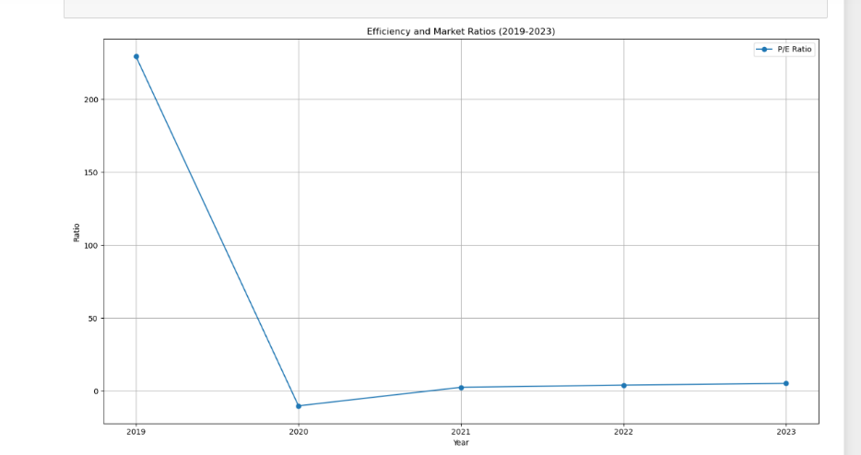

### Horizontal

|  |  |  |  |  |  |  |  |
| --- | --- | --- | --- | --- | --- | --- | --- |
| Horizontal Analysis | *Balance Sheet* | Share Capital | 0% | 0% | 0% | 0% | 0% |
|  |  | Capital & Other Reserves | 0% | 0% | 0% | 4% | 0% |
|  |  | Revenue Reserves | 0% | -22% | 38% | 9% | 45% |
|  |  | Surplus on Revaluation of Fixed Assets | 0% | 0% | 0% | 0% | 0% |
|  |  | Long-term Borrowing | 0% | -1% | -9% | -11% | 7% |
|  |  | Long-Term Lease Liabilities | 0% | 98% | -40% | -87% | -100% |
|  |  | Others | 0% | 14% | 8% | 12% | -35% |
|  |  | Trade & Others Payable | 0% | 22% | 44% | 45% | 46% |
|  |  | Interest & Markup | 0% | -30% | -32% | -19% | 73% |
|  |  | Short Term Borrowing | 0% | 4% | -10% | 20% | -20% |
|  |  | Current Portion Of Long Term Liabilities | 0% | -33% | 93% | 17% | 4% |
|  |  | Current Taxation | 0% | -9% | 46% | 37% | -35% |
|  |  | PPE | 0% | -2% | 3% | 4% | -2% |
|  |  | Investment Property | 0% | 24% | 1% | 1% | 19% |
|  |  | Long Term Investment | 0% | 12% | 102% | -59% | 3% |
|  |  | Long Term Loans and Advances | 0% | #DIV/0! | #DIV/0! | #DIV/0! | #DIV/0! |
|  |  | Long Term Deposits | 0% | 0% | 0% | 0% | 0% |
|  |  | Daferred Tax | 0% | #DIV/0! | #DIV/0! | #DIV/0! | #DIV/0! |
|  |  | Other | 0% | #DIV/0! | 79% | 13% | 12% |
|  |  | Store Spares & Loose Tools | 0% | -31% | 31% | 73% | -38% |
|  |  | Stock In Trade | 0% | -2% | 4% | -1% | -6% |
|  |  | Trade Debts | 0% | 27% | -11% | 41% | -36% |
|  |  | Loans & Advances | 0% | 43% | 22% | 73% | -35% |
|  |  | Other Receivables | 0% | -1% | -23% | 11% | 130% |
|  |  | Short Term Investment | 0% | -11% | 25% | -30% | 0% |
|  |  | Cash & Bank Balance | 0% | 29% | 14% | -62% | 332% |
|  | *Income Statement* | Sales | 0% | -23% | 44% | 21% | -32% |
|  |  | Cost of Sales | 0% | -22% | 39% | 20% | -23% |
|  |  | Administrative Expenses | 0% | 12% | 41% | 30% | -31% |
|  |  | Selling Cost & Distribution Cost | 0% | -16% | 39% | 24% | -30% |
|  |  | Other Operating Income | 0% | -80% | 5% | -79% | 3039% |
|  |  | Other Operating Expenses | 0% | -98% | 325% | 494% | -97% |
|  |  | Finance Cost | 0% | 91% | -26% | 1% | 45% |
|  |  | Provision For Taxation: Daferred | 0% | -95% | -61% | 4039% | -156% |
|  |  | Provision For Taxation: Current | 0% | -65% | 91% | 28% | -112% |

### Vertical

|  |  |  |  |  |  |  |  |
| --- | --- | --- | --- | --- | --- | --- | --- |
| Vertical Analysis | ***Balance Sheet*** | **Share Capital** | **18.33%** | **18.17%** | **17.64%** | **16.55%** | **16.73%** |
|  |  | Capital & Other Reserves | 11.62% | 11.52% | 11.19% | 10.89% | 11.01% |
|  |  | Revenue Reserves | 5.84% | 4.53% | 6.07% | 6.23% | 9.12% |
|  |  | Surplus on Revaluation of Fixed Assets | 0.07% | 0.07% | 0.07% | 0.07% | 0.07% |
|  |  | Long-term Borrowing | 28.23% | 27.73% | 24.42% | 20.44% | 22.20% |
|  |  | Others | 0.04% | 0.08% | 0.05% | 0.01% | 0.00% |
|  |  | Trade & Others Payable | 15.72% | 17.75% | 18.62% | 19.64% | 12.84% |
|  |  | Interest & Markup | 3.90% | 4.71% | 6.58% | 8.93% | 13.18% |
|  |  | Short Term Borrowing | 1.14% | 0.80% | 0.52% | 0.40% | 0.70% |
|  |  | Current Portion Of Long Term Liabilities | 11.73% | 12.15% | 10.60% | 11.95% | 9.68% |
|  |  | PPE | 2.36% | 1.57% | 2.94% | 3.22% | 3.38% |
|  |  | Long Term Loans and Advances | 1.02% | 0.92% | 1.30% | 1.68% | 1.11% |
|  |  | Long Term Deposits | 67.94% | 66.22% | 66.04% | 64.35% | 64.09% |
|  |  | Store Spares & Loose Tools | 2.32% | 2.85% | 2.78% | 2.63% | 3.17% |
|  |  | Stock In Trade | 0.70% | 0.78% | 1.54% | 0.59% | 0.61% |
|  |  | Trade Debts | 0.00% | 0.00% | 0.00% | 0.00% | 0.00% |
|  |  | Loans & Advances | 0.19% | 0.19% | 0.18% | 0.17% | 0.17% |
|  |  | Other Receivables | 0.00% | 0.00% | 0.00% | 0.00% | 0.00% |
|  |  | Cash & Bank Balance | 0.00% | 0.39% | 0.67% | 0.72% | 0.81% |
|  | *Income Statement* | Sales | 100.00% | 100.00% | 100.00% | 100.00% | 100.00% |
|  |  | Cost of Sales | 92.53% | 94.66% | 91.25% | 90.61% | 103.72% |
|  |  | Administrative Expenses | 1.29% | 1.88% | 1.84% | 1.98% | 2.04% |
|  |  | Selling Cost & Distribution Cost | 1.12% | 1.23% | 1.19% | 1.22% | 1.26% |
|  |  | Other Operating Income | 9.23% | 2.36% | 1.72% | 0.30% | 14.00% |
|  |  | Other Operating Expenses | 2.49% | 0.08% | 0.24% | 1.16% | 0.05% |
|  |  | Finance Cost | 2.19% | 5.47% | 2.81% | 2.34% | 5.01% |
|  |  | Provision For Taxation: Current | 1.02% | 0.07% | 0.02% | 0.67% | -0.56% |

## **Recommendation**

### For Investor:

* Exercise Caution: The company has shown inconsistent profitability, fluctuating ROE, and periods of high leverage. Investors should thoroughly analyze the company's recovery efforts and future earnings projections before making significant commitments.
* Focus on Long-Term Prospects: The improving trends in profitability (2023 ROE and margins) suggest a recovery phase. Investors with a long-term outlook may consider the company for diversification but only after ensuring its operational and cost efficiencies stabilize.
* Monitor Key Ratios: Pay close attention to liquidity (Current and Quick Ratios) and solvency (Debt-to-Equity and Times Interest Earned). Persistent challenges in meeting short-term obligations or high leverage might increase investment risk.

### For company:

* Cost Management: Rising costs, particularly in 2022 and 2023, have eroded profitability. The company must optimize operations, reduce inefficiencies, and negotiate better supplier terms to stabilize gross and net profit margins.
* Leverage Reduction: High reliance on debt has strained financial flexibility. Reducing long-term debt and avoiding excessive short-term borrowings will improve solvency and investor confidence.
* Revenue Growth Strategy: Diversify revenue streams and focus on sales growth to enhance asset turnover and profitability. Consistent earnings growth will also stabilize valuation ratios like P/E.
* Improve Working Capital Management: Address inefficiencies in receivables collection (Days Sales Outstanding) and inventory turnover to enhance liquidity and support smooth operations.
* Transparent Communication: Provide clear and consistent updates to stakeholders about recovery strategies and financial goals. Transparent reporting will bolster market confidence and attract potential investors.

## **Conclusion**

The company's financial performance has been inconsistent, marked by fluctuating profitability, high leverage, and operational inefficiencies, warranting caution for investors. However, recent trends suggest a potential recovery phase, making it suitable for long-term investors seeking diversification. To improve, the company must optimize cost management, reduce debt, diversify revenue streams, enhance working capital management, and maintain transparent communication. Investors should monitor key ratios, such as liquidity and solvency, and await consistent earnings growth and operational stability before making investment decisions. A cautious approach is advised, but the company's recovery efforts and future prospects make it worth consideration for investors with a long-term outlook.

# Nishat Chunian Limited

## **Introduction**

Welcome to Nishat Chunian Limited (NCL), a pioneering textile company in Pakistan, renowned for innovation, excellence, and unwavering commitment to quality. Since its inception in 1990, NCL has transformed from a modest spinning mill to a vertically integrated textile powerhouse, boasting an impressive annual production capacity of 85,000 tons of yarn and 72 million meters of greige fabric. Our state-of-the-art facilities encompass spinning, weaving, dyeing, printing, stitching, and power generation.

Guided by core values of honesty, commitment, passion, and innovation, NCL prioritizes employee growth, equal opportunities, and stakeholder value. As a public limited company incorporated in Pakistan, we deliver consistent profitable returns to shareholders while providing growth opportunities to talented individuals. With a rich history spanning over 34 years, NCL takes pride in being a fair employer, promoting diversity and inclusion, and contributing to Pakistan's economic growth, weaving a legacy of innovation, quality, and success.

## **Analysis**

### Liquidity Ratios

#### Current Ratio

Key Observation:

The current ratio improved significantly in 2022, reaching 1.77, due to an increase in current assets, particularly inventory and trade debts. However, the ratio declined to 1.27 in 2023, reflecting higher current liabilities, notably short-term borrowing and trade payables.

* Increase (2021 to 2022): A rise in stock-in-trade (from 18.21M to 21.17M) and trade debts (from 6.78M to 7.74M), coupled with a reduction in short-term borrowings, enhanced liquidity.
* Decrease (2022 to 2023): The decline is driven by a sharp increase in short-term borrowing (from 12.94M to 27.88M), which outpaced the growth in current assets.

#### Quick Ratio

Key Observation:

The quick ratio has consistently remained below 1, indicating dependency on inventory to meet short-term obligations. The highest ratio was in 2022 (0.65), driven by strong trade receivables and loans/advances.

* Decrease (2019 to 2020): A drop in trade debts (from 6.42M to 4.69M) and loans/advances (from 2.36M to 1.10M) reduced liquid assets relative to liabilities.
* Increase (2020 to 2022): Recovering trade debts (up to 7.74M) and growth in loans/advances (to 1.87M) improved the quick ratio.
* Decline (2022 to 2023): Despite an increase in trade debts (to 11.41M), the surge in liabilities, especially short-term borrowing, offset gains in liquidity.

#### Cash Ratio

The cash ratio has remained negligible throughout the period, indicating a lack of readily available cash to cover immediate liabilities. Even in 2023, cash and bank balances amounted to only 279K against total current liabilities of 37.71M.

* Minimal Improvement (2021 to 2022): Marginal increases in cash balances (from 272K to 209K) were insufficient compared to the overall growth in liabilities.
* Lack of Sustained Growth: Consistently low cash reserves signal operational challenges or a heavy reliance on non-cash assets to manage liquidity.

Overall Analysis:

* Rising Short-Term Liabilities: A consistent increase in short-term borrowing (from 20.09M in 2019 to 27.88M in 2023) and trade payables significantly impacted liquidity ratios negatively.
* Dependency on Inventory: The reliance on inventory as a major component of current assets weakened the quick ratio, as inventory is less liquid than trade debts or cash.
* Trade Debts and Receivables: Improvements in trade debts (e.g., from 6.78M in 2021 to 11.41M in 2023) temporarily strengthened liquidity but could not offset the liability surge.

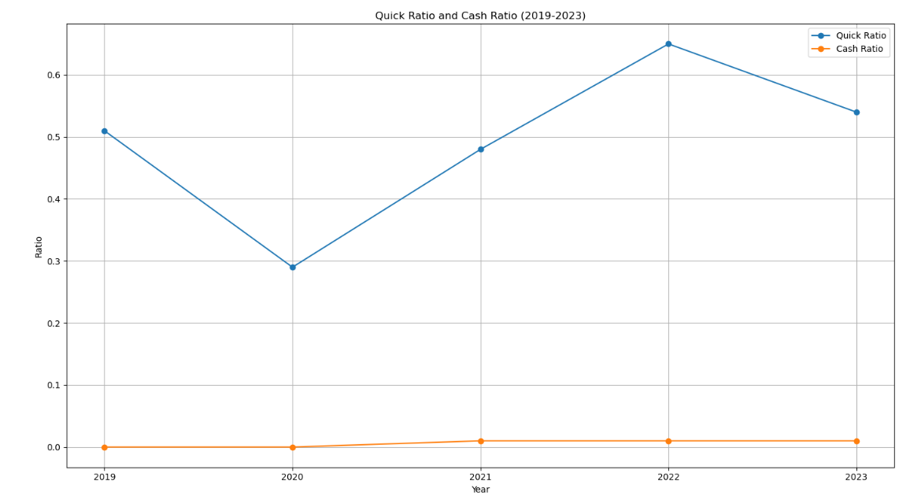

### Profitability Ratios

#### Gross Profit Margin

Key Observation:

The GPM peaked in 2022 (20.93%) due to relatively slower growth in cost of sales compared to revenue. However, in 2023, the GPM dropped to 9.74% as cost of sales increased significantly (24.5% from 2022 to 2023) compared to a smaller 9.1% increase in revenue.

* 2021–2022 Increase: Cost controls and efficient pricing strategies contributed to the higher GPM.
* 2023 Decline: Rising production costs (e.g., 61.04M in 2023 vs. 49.01M in 2022) outpaced revenue growth, reducing profitability.

Cost Controls:

The company managed to keep the cost of sales growth (from 40.31M in 2021 to 49.01M in 2022, a 21.6% increase) relatively aligned with the revenue growth (from 49.28M in 2021 to 61.99M in 2022, a 25.7% increase). This demonstrates effective cost management, ensuring that expenses did not escalate disproportionately with sales.

Efficient Pricing Strategies:

Improved pricing mechanisms may have helped the company secure better margins on its products, contributing to the peak GPM in 2022.

Sharp Increase in Cost of Sales:

The cost of sales rose from 49.01M in 2022 to 61.04M in 2023 (+24.5%). This sharp increase in production and operational expenses outpaced the 9.1% revenue growth (from 61.99M in 2022 to 67.63M in 2023), significantly compressing the GPM.

Input Cost Inflation:

Higher raw material, labor, or energy costs likely drove up production expenses, which were not adequately offset by proportional increases in selling prices.

Operational Inefficiencies:

Inefficiencies in managing production processes may have further inflated costs, eroding the profitability of each unit sold.

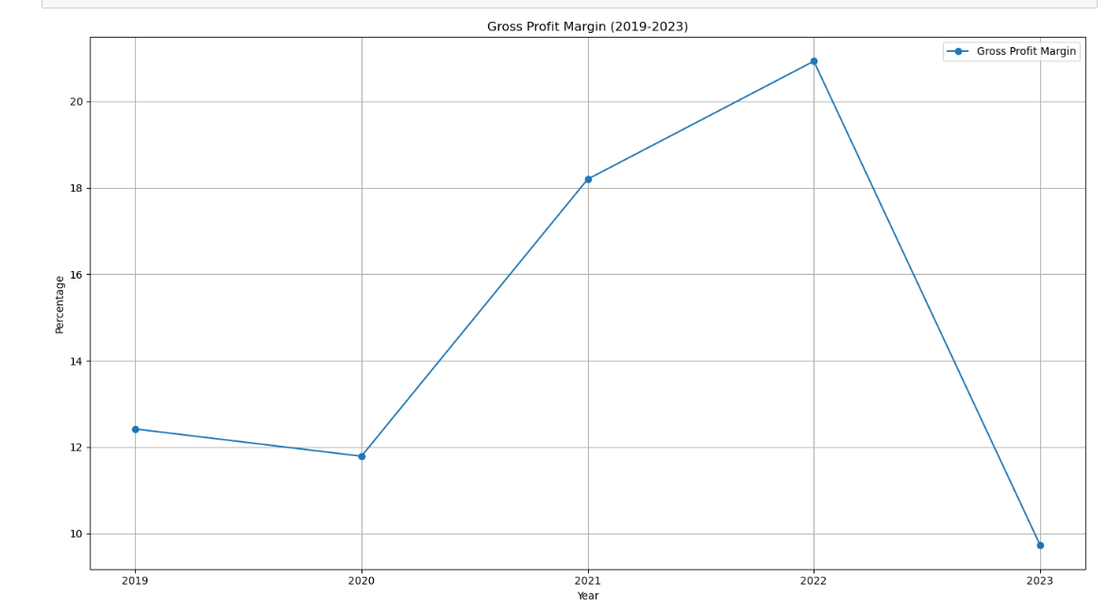

#### Operating Profit Margin

Key Observation:

Operating profitability followed a similar trend to GPM. The ratio peaked in 2022 (17.02%) but fell drastically in 2023 to 7.88%. Higher finance costs in 2023 (5.42M) and elevated selling/distribution expenses contributed to the decline.

* 2020 Decline: A sharp rise in finance costs (2.66M vs. 2.18M in 2019) and lower operating income (reduction in other income) contributed to the drop.
* 2023 Decline: A spike in selling/distribution costs (1.61M) and administrative expenses (497K) squeezed operating profitability.

Finance Costs as a Critical Factor:

Rising finance costs over the years highlight a dependency on debt financing, which significantly reduces profitability, especially during periods of increased interest rates or higher borrowing levels.

Cost-Intensive Revenue Growth:

While revenues grew in 2023, the concurrent rise in cost of sales and operating expenses outweighed the benefits of increased sales, leading to a weaker margin.

Need for Cost Optimization:

Administrative and selling expenses, while necessary for growth, need to be closely monitored and optimized to avoid excessive strain on profitability.

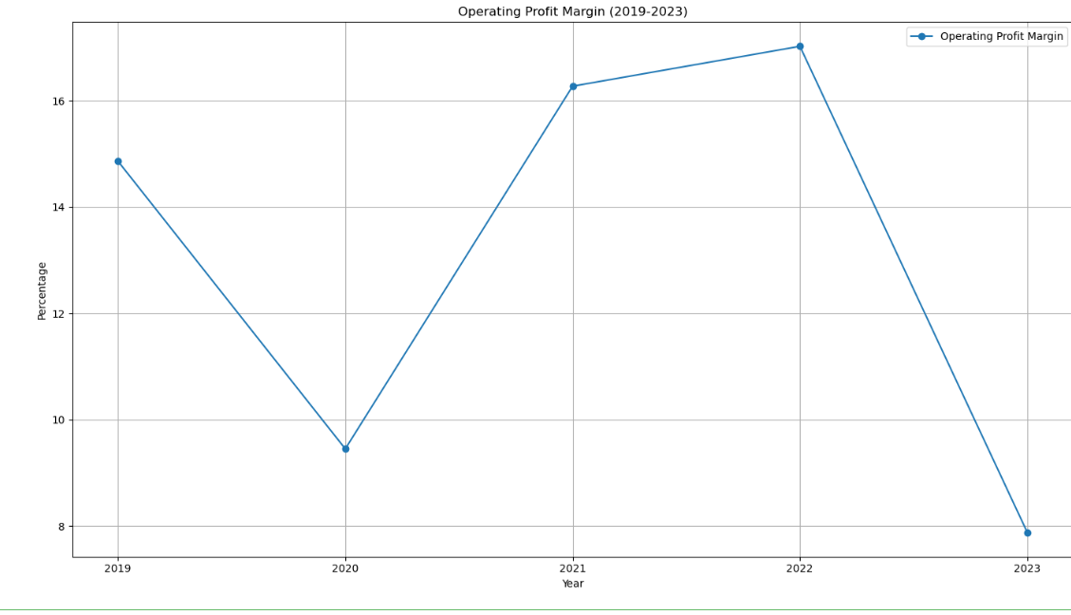

#### Net Profit Margin

Key Observation:

The NPM reflects a similar pattern to OPM, with strong profitability in 2021–2022 followed by a negative margin in 2023. This is largely due to the exponential increase in finance costs (from 2.20M in 2022 to 5.41M in 2023) and the rising tax burden (912K in 2023).

* 2020 Decline: The negative margin stemmed from higher finance costs, falling operating income, and reduced sales.
* 2023 Decline: High finance costs and reduced control over operational expenses led to negative net profitability.

Higher Finance Costs:

Finance costs increased from 2.18M in 2019 to 2.66M in 2020 (+22%). This rise significantly reduced the net profit, as the company had to allocate more income to debt servicing.

Falling Operating Income:

Operating income declined due to the sharp reduction in other operating income, dropping from 2.45M in 2019 to 454K in 2020. This loss of supplementary revenue further strained overall profitability.

Sales Decline:

Net sales fell from 39.34M in 2019 to 35.67M in 2020 (-9.3%), driven by decreased demand or external economic factors. This revenue decline, combined with rising costs, pushed the company into a negative margin.

Exponential Increase in Finance Costs:

Finance costs surged from 2.20M in 2022 to 5.41M in 2023 (+146%), primarily due to increased borrowings or higher interest rates. The elevated debt servicing burden was a major factor behind the negative NPM.

Rising Tax Burden:

The company faced a tax expense of 912K in 2023, compared to 879K in 2022, further reducing net profit. While sales grew during this period, the tax expense ate into the company's earnings.

Operational Inefficiencies:

High administrative costs (497K) and elevated selling/distribution costs (1.61M) eroded profitability despite increasing revenues. Operational inefficiencies indicate weak cost control measures in the face of rising sales.

Cost of Sales Growth:

The cost of sales rose significantly from 49.01M in 2022 to 61.04M in 2023 (+24.5%), outpacing the revenue growth of 9%. This imbalance negatively impacted overall margins.

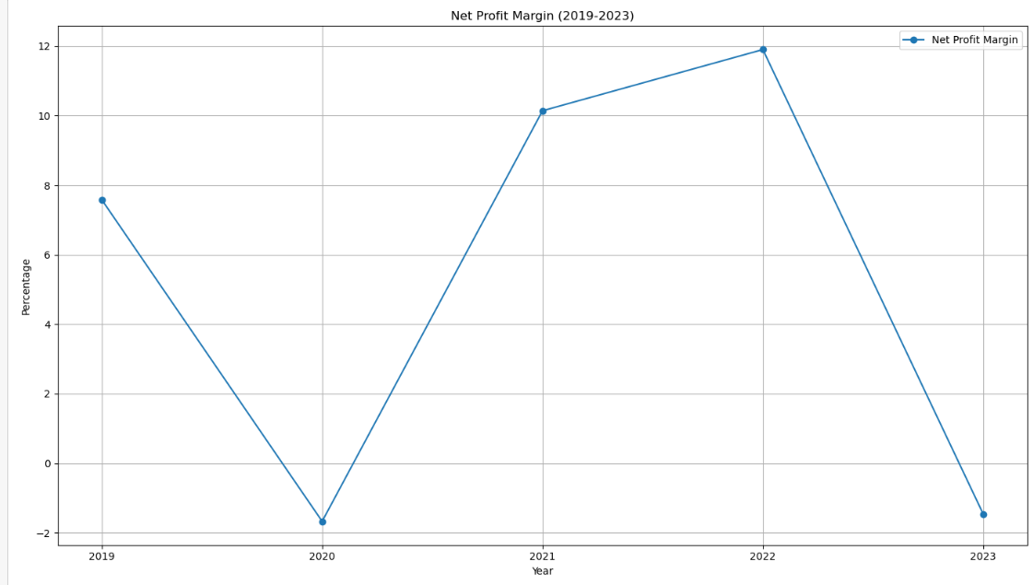

#### Dupont Analysis

2019 (ROE: 20.7%)

NPM (7.58%): Positive net profit margins supported by steady revenues and manageable costs.

ATO (96.06%): Efficient use of assets to generate sales.

FL (283.65%): Moderate financial leverage amplified the effect of profits on equity returns.

Conclusion: Strong ROE due to positive profitability and effective asset utilization.

2020 (ROE: -4.4%)

NPM (-1.67%): Negative profitability due to a sharp rise in finance costs (2.66M) and declining revenues (35.66M vs. 39.34M in 2019).

ATO (75.64%): Decline in asset turnover, reflecting reduced operational efficiency.

FL (350.14%): Increased financial leverage indicated higher reliance on debt, exacerbating the impact of negative margins.

Conclusion: The drop in ROE was driven by falling profits and reduced efficiency, with high debt amplifying losses.

2021 (ROE: 26.8%)

NPM (10.14%): Recovery in profitability due to improved cost management and higher sales (49.28M, a 38.2% increase).

ATO (96.87%): Stabilization in asset turnover, indicating efficient asset use.

FL (272.53%): Decline in financial leverage reduced the debt burden, improving equity returns.

Conclusion: The improvement in ROE was driven by higher profitability and better cost control.

2022 (ROE: 30.4%)

NPM (11.90%): Further improvement in net profit margin due to strong revenue growth (61.99M) and controlled costs.

ATO (105.55%): Peak asset turnover, showing optimal utilization of assets to generate revenue.

FL (242.17%): Declining leverage reduced financial risks, contributing to robust ROE.

Conclusion: ROE peaked due to the combined effects of high profitability and operational efficiency.

2023 (ROE: -4.8%)

NPM (-1.46%): Negative profitability caused by soaring finance costs (5.41M) and slower revenue growth (67.63M, a 9.1% increase).

ATO (98.17%): Slight decline in asset turnover, reflecting operational challenges.

FL (337.29%): Increased financial leverage added strain, amplifying the negative impact of losses.

Conclusion: ROE turned negative due to declining profitability and higher financial leverage, highlighting inefficiencies and cost pressures.

Net Profit Margin (NPM):

The key driver of ROE in 2021 and 2022 was the improvement in NPM due to effective cost management and revenue growth.

Negative margins in 2020 and 2023 resulted from rising costs and inefficiencies.

Asset Turnover (ATO):

Asset efficiency peaked in 2022, contributing to strong ROE.

Slight declines in 2020 and 2023 reflected reduced operational effectiveness.

Financial Leverage (FL):

Leverage played a dual role: amplifying positive ROE during profitable years (e.g., 2019, 2021) but worsening losses during negative-margin years (e.g., 2020, 2023).

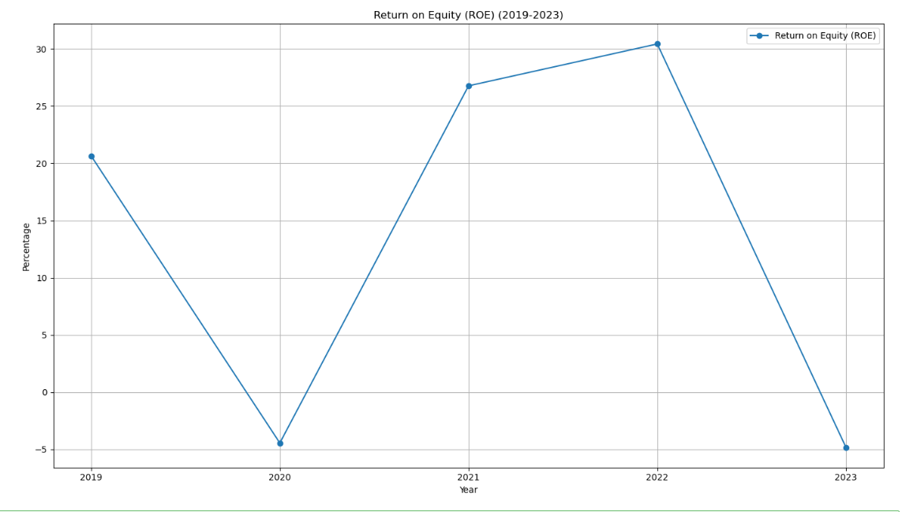

### Solvency Ratios

#### Debt to Equity Ratio

Key Observation:

Rising long-term debt was the primary driver, especially in 2022 and 2023, as the company relied on borrowings to fund operations and investments. Declining equity in 2020 and 2023 due to negative profitability also worsened the ratio.

* 2019: D/E (0.2384): The company maintained a low debt-to-equity ratio, showing strong reliance on equity financing.
* 2020: D/E (0.4403): A significant rise in debt-to-equity resulted from a sharp increase in long-term borrowings (6.01M vs. 3.66M in 2019) and declining equity (13.64M).
* 2021: D/E (0.3371): Slight improvement as equity increased significantly to 18.99M, while long-term liabilities stabilized.
* 2022: D/E (0.5476): A sharp rise in debt-to-equity due to increased long-term borrowings (13.44M) and equity growth to 24.54M.
* 2023: D/E (0.6055): Highest ratio over the period, driven by long-term borrowing (12.54M) and a drop in equity to 20.71M, reflecting financial strain.

#### Times Interest Earned

Key Observation:

The TIE ratio was 1 in 2019 but dropped to 0 from 2020 onward, indicating insufficient earnings to cover interest expenses. EBIT consistently underperformed, particularly in 2020 and 2023, due to rising finance costs and operational inefficiencies. Finance costs rose significantly, from 2.17M in 2019 to 5.42M in 2023, driven by higher debt levels.

* 2019:TIE (1): EBIT was just sufficient to cover interest payments, signaling borderline financial stability.
* 2020:EBIT was negative, unable to cover interest expenses (2.66M).
* 2021:EBIT remained insufficient to meet interest obligations (1.75M finance cost).
* 2022:EBIT failed to cover growing interest expenses (2.20M).
* 2023:Finance costs ballooned to 5.42M, far exceeding earnings.

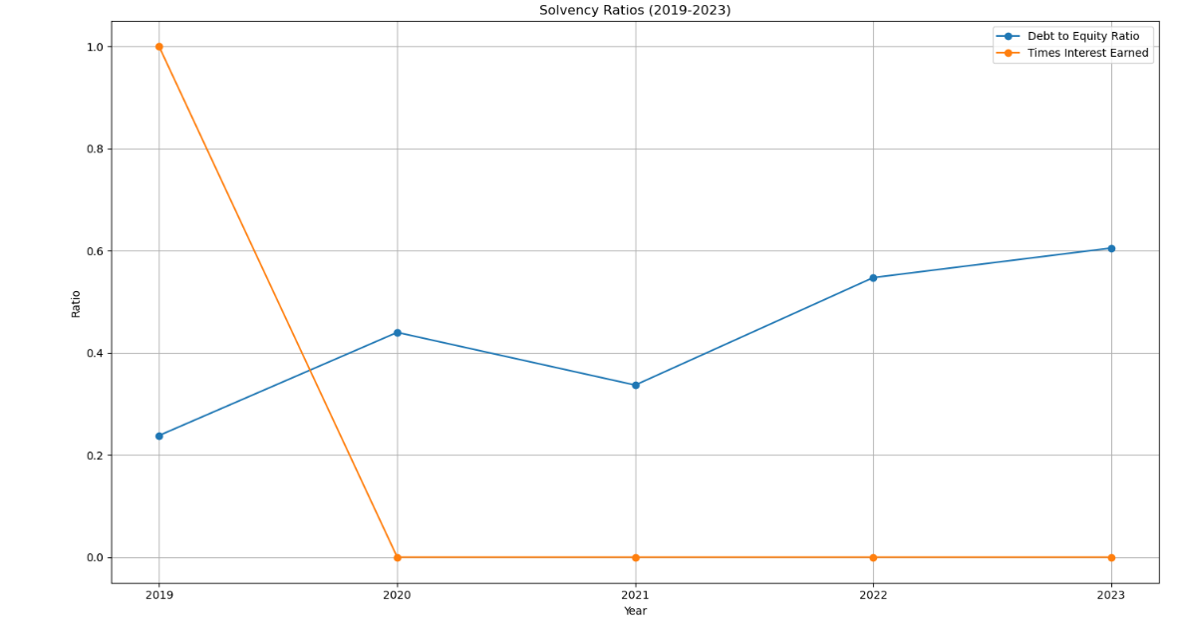

### Efficiency and Market Ratios

#### Inventory Turnover Ratio

Key Observation:

The ratio gradually improved from 0 in 2019 to 3 in 2023, indicating better inventory management. 2019: Inefficient stock management caused stagnation. 2020–2023: Gradual improvement due to better inventory controls and alignment of stock levels with sales demand.

* 2019 ITR (0): Inefficient inventory management, possibly due to excess inventory levels or negligible movement in stock.
* 2020 ITR (2): Inventory turnover improved as cost of goods sold increased relative to average inventory, signaling more effective stock utilization.
* 2021 ITR (2): The ratio stabilized, showing consistent inventory management practices.
* 2022 ITR (2): Consistent inventory turnover, though no significant improvement was observed.
* 2023 ITR (3): The highest inventory turnover ratio in the period, reflecting efficient stock usage and improved demand forecasting.

Continue improving inventory forecasting and management to sustain high turnover. Avoid stockouts by aligning inventory levels with sales trends.

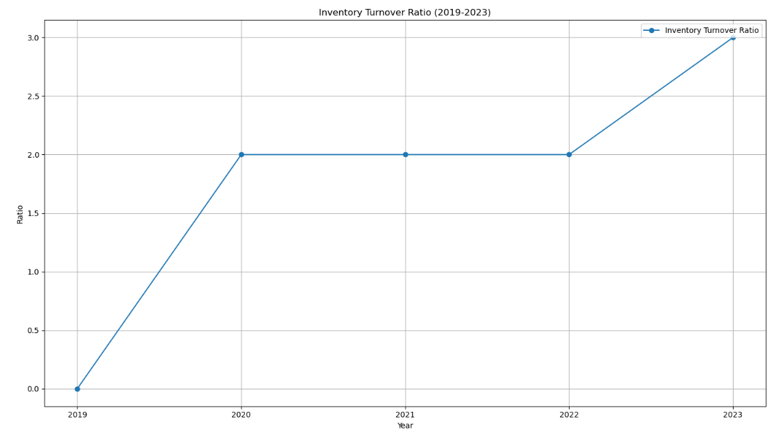

#### Days Sales Outstanding (DSO)

Key Observation:

DSO showed a steep decline from ****2406 days**** in 2019 to ****85–103 days**** during 2020–2023, reflecting improved receivables collection efficiency in recent years.

* 2019: Poor credit controls led to excessively high DSO.
* 2020–2021: Significant reductions due to improved collection practices and stricter credit policies.
* 2023: Slight rise as credit terms may have been loosened to stimulate sales.

2019: DSO (2406 days) Extremely high DSO indicates a significant delay in collecting receivables, reflecting poor credit control.

2020: DSO (114 days) Collection efficiency improved dramatically due to tighter credit policies or better receivables management.

2021: DSO (85 days) Further improvement in collection efficiency, likely due to sustained efforts in managing receivables.

2022: DSO (86 days) Collection time increased slightly but remained stable overall.

2023: DSO (103 days) A slight increase in DSO indicates a small delay in receivables collection, possibly due to larger or more complex sales transactions.

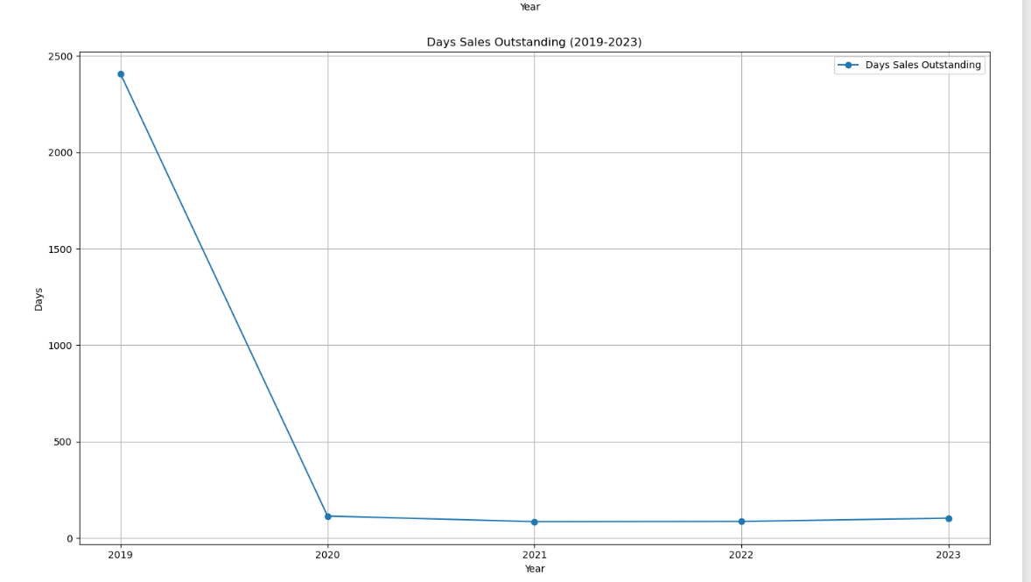

#### Price-to-Earnings (P/E) Ratio

Key Observation:

* Earnings Performance: Negative EPS in 2020 and 2023 significantly impacted the P/E ratio, driving it into negative territory.
* Market Price Volatility: Declining investor confidence during unprofitable years led to a drop in market price, compounding the P/E ratio decline.
* Operational Challenges: Rising finance costs, administrative expenses, and weak profitability metrics directly affected investor sentiment.

Year Wise Analysis:

2019 (2.4):

Market Sentiment: Positive but cautious due to low earnings per share (EPS).

Reason: A relatively low P/E ratio suggests investors had limited confidence in future growth despite stable operations.

2020 (-20.6):

Market Sentiment: Extremely negative, driven by significant losses (negative EPS).

Reason: The company faced rising costs and declining profitability, leading to a market price drop and a negative P/E ratio.

2021 (2.2):

Market Sentiment: Slight recovery in investor confidence.

Reason: Improved profitability led to positive EPS, restoring a modest but positive P/E ratio.

2022 (0.7):

Market Sentiment: Declining optimism despite positive EPS.

Reason: Weak earnings growth combined with market skepticism about future profitability.

2023 (-6.0):

Market Sentiment: Strongly negative.

Reason: Losses (negative EPS) and declining operational efficiency led to a drop in market valuation and negative investor sentiment.

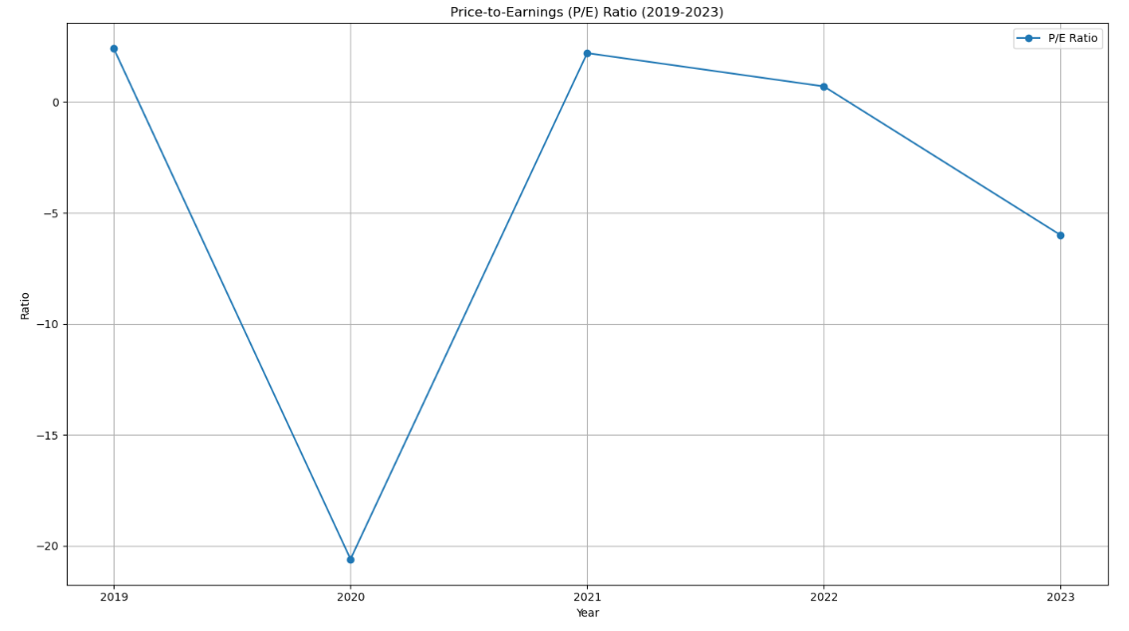

### Horizontal Analysis

|  |  |  |  |  |  |  |  |
| --- | --- | --- | --- | --- | --- | --- | --- |
| Horizontal Analysis | *Balance Sheet* | Share Capital | 0% | 0% | 0% | 0% | 0% |
|  |  | Capital & Other Reserves | 0% | 0% | 0% | 0% | 0% |
|  |  | Revenue Reserves | 0% | -14% | 50% | 35% | -18% |
|  |  | Surplus on Revaluation of Fixed Assets | 0% | #DIV/0! | #DIV/0! | #DIV/0! | #DIV/0! |
|  |  | Long-term Borrowing | 0% | 64% | 7% | 110% | -7% |
|  |  | Long-Term Lease Liabilities | 0% | #DIV/0! | 4% | -25% | 23% |
|  |  | Others | 0% | #DIV/0! | #DIV/0! | 335% | -19% |
|  |  | Trade & Others Payable | 0% | 56% | -8% | 11% | -7% |
|  |  | Interest & Markup | 0% | 7% | -41% | 89% | 172% |
|  |  | Short Term Borrowing | 0% | 12% | -16% | -32% | 115% |
|  |  | Current Portion Of Long Term Liabilities | 0% | -53% | 445% | -16% | -9% |
|  |  | Current Taxation | 0% | #DIV/0! | #DIV/0! | #DIV/0! | -4% |
|  |  | PPE | 0% | 49% | 4% | 31% | 5% |
|  |  | Investment Property | 0% | #DIV/0! | #DIV/0! | #DIV/0! | #DIV/0! |
|  |  | Long Term Investments | 0% | -43% | 0% | -73% | 0% |
|  |  | Long Term Loans and Advances | 0% | -25% | 57% | 16% | -48% |
|  |  | Long Term Deposits | 0% | 21% | -4% | 1% | 10% |
|  |  | Deferred Tax | 0% | #DIV/0! | #DIV/0! | #DIV/0! | #DIV/0! |
|  |  | Others | 0% | 13819% | 16% | -30% | 53% |
|  |  | Store Spares & Loose Tools | 0% | 113% | 8% | 0% | 45% |
|  |  | Stock In Trade | 0% | 23% | -6% | 16% | 11% |
|  |  | Trade Debts | 0% | -27% | 45% | 14% | 47% |
|  |  | Loans & Advances | 0% | -53% | 195% | -43% | 118% |
|  |  | Other Receivables | 0% | -37% | -12% | 64% | 6% |
|  |  | Short Term Investments | 0% | 83% | 316% | -63% | 37% |
|  | *Income Statement* | Cash & Bank Balance | 0% | 168% | 474% | -23% | 34% |
|  |  | Sales | 0% | -9% | 38% | 26% | 9% |
|  |  | Cost of Sales | 0% | -9% | 28% | 22% | 25% |
|  |  | Administrative Expenses | 0% | 17% | -4% | 66% | -4% |
|  |  | Selling Cost & Distribution Cost | 0% | -8% | 34% | 47% | -5% |
|  |  | Other Operating Income | 0% | -82% | 90% | -14% | 26% |
|  |  | Other Operating Expenses | 0% | -65% | 258% | 177% | -92% |
|  |  | Finance Cost | 0% | 22% | -34% | 26% | 146% |
|  |  | Provision For Taxation: Deferred | 0% | #DIV/0! | 52% | -100% | #DIV/0! |
|  |  | Provision For Taxation: Current | 0% | 74% | -41% | 71% | 4% |

### Vertical Analysis

|  |  |  |  |  |  |  |  |
| --- | --- | --- | --- | --- | --- | --- | --- |
| Vertical Analysis | *Balance Sheet* | Share Capital | 5.52% | 5.03% | 4.64% | 4.04% | 3.44% |
|  |  | Capital & Other Reserves | 1.38% | 1.26% | 1.16% | 1.01% | 0.86% |
|  |  | Revenue Reserves | 28.35% | 22.27% | 30.90% | 36.24% | 25.35% |
|  |  | Surplus on Revaluation of Fixed Assets | 0.00% | 0.00% | 0.00% | 0.00% | 0.00% |
|  |  | Long-term Borrowing | 8.41% | 12.58% | 12.37% | 22.61% | 17.95% |
|  |  | Others | 0.00% | 0.15% | 0.14% | 0.09% | 0.10% |
|  |  | Trade & Others Payable | 0.00% | 0.00% | 0.37% | 1.40% | 0.97% |
|  |  | Interest & Markup | 6.65% | 9.44% | 8.00% | 7.77% | 6.15% |
|  |  | Short Term Borrowing | 0.99% | 0.97% | 0.52% | 0.86% | 2.00% |
|  |  | Current Portion Of Long Term Liabilities | 46.18% | 47.23% | 36.50% | 21.78% | 39.92% |
|  |  | PPE | 2.51% | 1.07% | 5.39% | 3.93% | 3.06% |
|  |  | Long Term Loans and Advances | 0.00% | 0.00% | 0.00% | 0.25% | 0.21% |
|  |  | Long Term Deposits | 25.54% | 34.70% | 33.27% | 38.02% | 33.89% |
|  |  | Store Spares & Loose Tools | 0.00% | 0.00% | 0.00% | 0.00% | 0.00% |
|  |  | Stock In Trade | 7.61% | 3.95% | 3.64% | 0.86% | 0.73% |
|  |  | Trade Debts | 0.04% | 0.02% | 0.04% | 0.04% | 0.02% |
|  |  | Loans & Advances | 0.06% | 0.07% | 0.06% | 0.05% | 0.05% |
|  |  | Other Receivables | 0.00% | 0.00% | 0.00% | 0.00% | 0.00% |
|  |  | Cash & Bank Balance | 0.00% | 0.20% | 0.21% | 0.13% | 0.16% |
|  | *Income Statement* | Sales | 100.00% | 100.00% | 100.00% | 100.00% | 100.00% |
|  |  | Cost of Sales | 87.58% | 88.21% | 81.80% | 79.07% | 90.26% |
|  |  | Administrative Expenses | 0.71% | 0.91% | 0.63% | 0.83% | 0.74% |
|  |  | Selling Cost & Distribution Cost | 2.40% | 2.44% | 2.35% | 2.75% | 2.39% |
|  |  | Other Operating Income | 6.24% | 1.27% | 1.75% | 1.20% | 1.39% |
|  |  | Other Operating Expenses | 0.70% | 0.27% | 0.69% | 1.52% | 0.12% |
|  |  | Finance Cost | 5.54% | 7.46% | 3.54% | 3.56% | 8.01% |
|  |  | Provision For Taxation: Current | 0.00% | 1.24% | 1.37% | 0.00% | 0.00% |

## **Recommendation**

### For Investor

Given its erratic profitability and mounting debt, investors should proceed with care when contemplating an investment in this firm. Notwithstanding the company's robust rebound in 2021 and 2022, which included robust net profit margins and operational effectiveness, the 2023 downturn exposes serious weaknesses, including rising financing costs, growing operational inefficiencies, and declining profitability. For investors looking for steady profits, the company's low Times Interest Earned (TIE) ratio—which indicates its inability to pay interest expenses—is a serious warning signal.

Improved inventory turnover and receivables management may help the firm recover, but operational inefficiencies and a growing reliance on debt financing—particularly long-term borrowings—may endanger long-term viability. If the business can show significant gains in cost control and liquidity, investors with a high risk tolerance may think about making an investment. However, those seeking more secure investments should wait until the company addresses its solvency issues and optimizes its operations.

### For Company

Cost Control and Efficiency Improvements:

The company needs to streamline operations by addressing rising finance costs, improving cost efficiency, and optimizing its administrative and selling expenses. Rising production costs, coupled with weak control over operational expenditures, have compressed profitability, especially in 2023. Tightening cost control measures is essential to enhance profit margins moving forward.

Debt Management and Financial Restructuring:

The increasing debt-to-equity ratio and insufficient earnings to cover interest expenses signal the need for a reevaluation of the company's debt strategy. The company should consider refinancing options to reduce short-term borrowing costs, extend repayment terms, and decrease its overall debt load. Reducing financial leverage would help lower the risks associated with interest rate hikes and improve its Times Interest Earned ratio.

Inventory and Receivables Management:

While the company has made significant strides in improving inventory turnover and reducing Days Sales Outstanding (DSO), it should continue refining its inventory management and forecasting practices. Efficient inventory controls will help maintain high turnover rates, avoid stockouts, and minimize carrying costs. Further, optimizing credit policies to maintain healthy receivables collection cycles will improve liquidity.

Revenue and Profitability Strategies:

Despite a slight revenue growth in 2023, the company must focus on improving its profitability by managing cost increases more effectively. This includes improving pricing strategies and exploring ways to reduce the cost of goods sold. Diversifying revenue streams, especially into higher-margin products, could help mitigate the impact of rising production costs and enhance profitability.

Investor Confidence and Communication:

Given the volatile market sentiment and negative P/E ratios in recent years, the company should prioritize transparent communication with investors regarding its recovery strategy. Regular updates on financial performance, cost optimization measures, and the steps being taken to address the debt burden will help rebuild investor confidence.

Focus on Profitability over Growth:

The company's focus should shift from aggressive growth to sustainable profitability. While increasing sales is important, controlling operating and financial expenses will ensure that the growth translates into long-term financial health.

## **Conclusion**

Nishat Chunian Limited faces significant financial challenges, marked by rising finance costs, operational inefficiencies, and declining profitability. Despite promising growth in 2021-2022, the company's high debt burden and operational costs led to negative net profitability in 2023. This presents a high-risk profile for investors, exacerbated by negative profitability in 2020 and 2023, and increasing reliance on debt financing. However, with improvements in inventory management and receivables collection, there is potential for recovery if the company addresses its financial and operational challenges. To regain stability and long-term profitability, Nishat Chunian Limited must focus on cost optimization, debt restructuring, and operational efficiency, while effectively communicating its recovery strategy to investors.

# Ansari Sugar Mills Limited

## **Introduction**

Welcome to Ansari Sugar Mills Limited, a leading manufacturer of high-quality white sugar in Pakistan. Since its incorporation in 1989, the company has been committed to producing cost-effective products that meet international standards. Guided by a visionary leadership team, including CEO Khawaja Anver Majid, Chairperson Aurangzeb Khan, and Company Secretary Imran Hameed, Ansari Sugar Mills aims to contribute to the national economy while promoting professionalism, research, and development. With a focus on adopting latest technology and advancements, the company strives to create reliable products and improve sugar cane yield and recovery through technical expertise and knowledge sharing with growers.

## **Analysis**

### Liquidity Ratios

#### Current Ratio

Key Observation:

The current ratio has steadily declined over the years, indicating decreasing ability to cover short-term liabilities using current assets. A ratio below 1 in the latter years signifies potential liquidity challenges.

Reason For decline:

* Trade and other payables increased from 407M (Year 1) to 487M (Year 5).
* Short-term borrowings and the current portion of long-term liabilities grew significantly over the years, with the current portion rising from 757M to 2.78B (+267%).
* Inventory levels grew modestly (+25%), but receivables such as trade debts appeared only in later years, peaking at 248M in Year 5.
* Cash and bank balances dropped sharply to 20M in Year 5, down from 388M in Year 4.

#### Quick Ratio

Key Observation:

The quick ratio measures the company's ability to meet its short-term obligations using its most liquid assets, excluding inventory. A consistent decline in this ratio suggests a weakening position in terms of liquidity and reliance on less liquid current assets, such as inventory, to cover liabilities.

Reason For Decline:

* The cash and bank balances dropped sharply from 328M in Year 1 to only 20M in Year 5.
* This decline was likely due to:
* Rising financial costs: Interest and markup payments increased significantly (from 722M in Year 1 to 3.29B in Year 5), consuming much of the available cash.
* Operational challenges: The company may have used cash to cover rising operating expenses, payments to creditors, or debt obligations.
* The near-zero cash balance in Year 5 drastically weakened the company’s immediate liquidity, making it harder to meet short-term liabilities without selling inventory.
* Inventory grew from 2.36B in Year 1 to 2.96B in Year 5, accounting for a substantial share of total current assets. While inventory is an asset, it is not as liquid as cash or receivables since it requires time and effort to convert into cash.
* An over-reliance on inventory implies that if immediate obligations arise, the company may struggle to generate cash without delays. Additionally:
* Slow inventory turnover could lead to liquidity bottlenecks.
* Unsold or obsolete inventory might further reduce the effective value of the company's assets.

#### Cash Ratio

Key Observation:

The cash ratio has declined to 0.00 in Year 5, reflecting a critical liquidity crunch. This indicates the company had virtually no cash to meet immediate obligations by the end of Year 5.

Reason for Decline:

* Severe cash depletion: Cash balances dropped from 328M in Year 1 to just 20M in Year 5, primarily due to rising operational and financial costs.
* High short-term liabilities: Interest and markup payments ballooned from 722M in Year 1 to 3.29B in Year 5, absorbing cash flow.

Cash dropped drastically from 328M to 20M, with no corresponding increase in other liquid assets, leaving the company ill-prepared to handle immediate obligations.

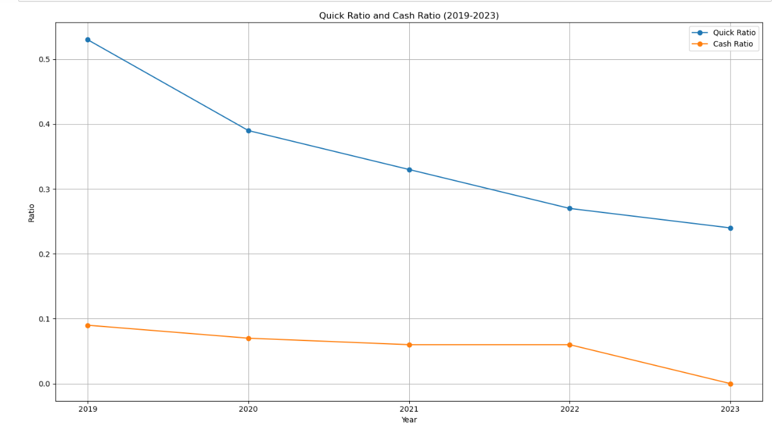

### Profitability Ratios

#### Gross Profit Margin

Key Observation:

The GPM improved significantly from Year 1 to Year 2, reflecting better cost management relative to sales. However, it declined in Year 4 before recovering slightly in Year 5.

Reasons for fluctuations:

* Increase (Year 1 → Year 3): A reduction in the Cost of Sales as a percentage of sales improved gross margins, likely due to operational efficiencies.
* Decline (Year 3 → Year 4): Rising Cost of Sales (from 275M to 717M) in Year 4 outpaced revenue growth, shrinking the GPM.
* Recovery (Year 4 → Year 5): Cost management partially recovered in Year 5, improving the GPM slightly.

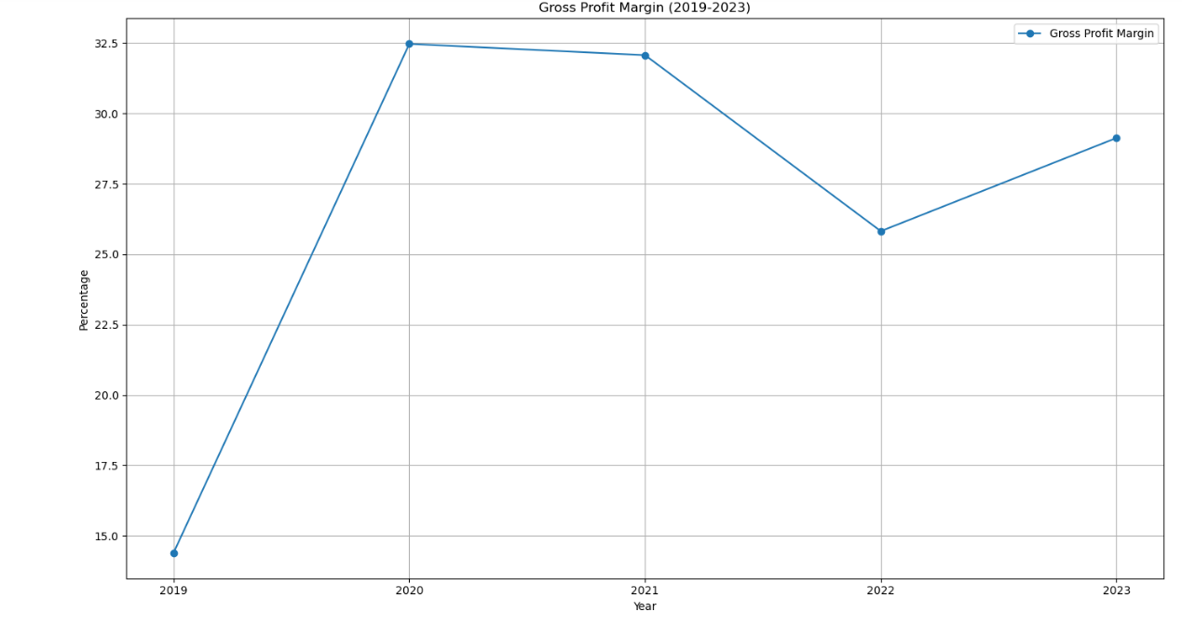

#### Operating Profit Margin

Key Observation:

The Operating Profit Margin (OPM) of Ansar Sugar Mill reflects the company’s ability to generate profit from core operations.

* Initial Decline (Year 1 → Year 2): OPM dropped from 7.33% to 4.38%. This decline was driven by: A sharp fall in revenues from 438M to 176M, reducing the ability to cover fixed costs. Rising selling costs and relatively unchanged administrative expenses, which put pressure on operating income.
* Recovery (Year 2 → Year 3): OPM rebounded to 17.94% in Year 3, driven by: Revenue recovery to 405M, more than doubling from Year 2.Improved cost efficiency in selling and administrative expenses, allowing higher profits per dollar of sales. OPM rebounded to 17.94% in Year 3, driven by: Revenue recovery to 405M, more than doubling from Year 2.Improved cost efficiency in selling and administrative expenses, allowing higher profits per dollar of sales.
* Stabilization and Peak (Years 4–5):OPM peaked at 19.83% (Year 4) and stabilized at 20.17% (Year 5). Factors contributing to this included: Controlled operating expenses (e.g., administrative costs stayed consistent).Continued revenue growth, with sales reaching a high of 967M in Year 4, providing better fixed cost absorption.

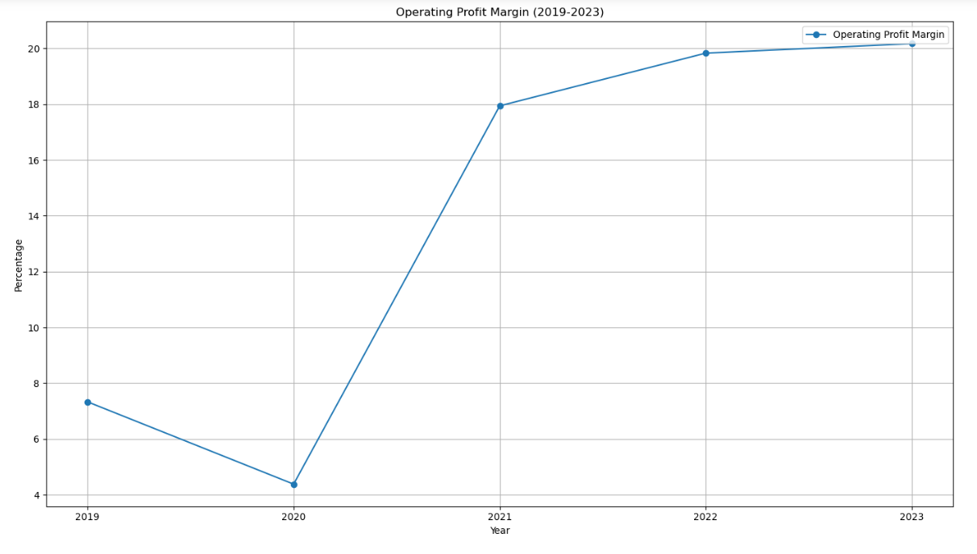

#### Net Profit Margin

Key Observation:

The Net Profit Margin (NPM) of Ansar Sugar Mill has remained negative throughout the five-year period, despite showing some improvement in Years 3 and 4. This indicates persistent challenges in converting revenues into net profit, primarily due to high finance costs, tax burdens, and revenue volatility.

Initial Decline (Year 1 → Year 2):

NPM dropped from -141.62% in Year 1 to -437.49% in Year 2.

This sharp decline was caused by: A significant revenue dip (438M → 175M), resulting in lower gross and operating profits. Finance costs rising to 607M, consuming nearly all earnings before tax.

Partial Recovery (Year 2 → Year 3):

NPM improved to -111.54% in Year 3, driven by: Revenue recovery to 405M, increasing gross and operating profits. Slightly lower finance costs (421M), easing the burden on net income.

Stabilization and Decline (Years 4–5):NPM improved further to -55.34% in Year 4 but dropped again to -143.44% in Year 5. Year 4 improvements stemmed from record revenues (967M) and stable operating expenses.

The decline in Year 5 was due to:

Revenue falling to 664M, reducing gross profit. Finance costs spiking to 953M, outstripping gross and operating income.

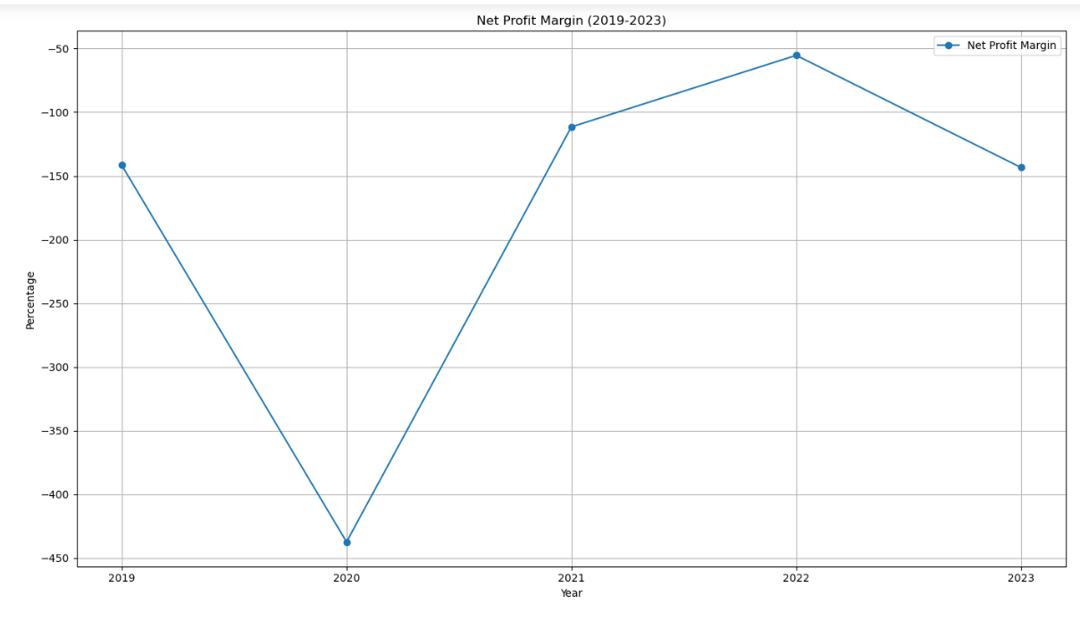

#### Dupont Analysis

Detailed Insights

Profitability (NPM)

NPM has been consistently negative due to high finance costs and tax provisions. Year 4 saw some improvement due to increased sales, but the net margin remained negative.

Efficiency (Asset Turnover)

Low asset turnover indicates inefficient use of assets to generate revenue. The company’s AT improved significantly in Year 4 (0.105) due to higher sales but dropped again in Year 5.

Leverage (Equity Multiplier)

The EM has increased steadily, peaking at 6.82 in Year 5, indicating a high reliance on debt financing. This high leverage increases financial risk and contributes to the deterioration of ROE.

ROE

ROE has remained negative throughout, worsening significantly in Year 5 due to: A decline in sales and net income. Increased leverage, which amplifies losses. Persistent inefficiencies in asset utilization.

Key Takeaways from DuPont Analysis

Profitability Challenges: Negative NPM is the primary driver of poor ROE.

High Leverage: While leverage boosts EM, it increases financial instability, as the company struggles to manage interest expenses.

Asset Utilization Issues: Improving AT by better utilizing assets to generate consistent sales could help offset other weaknesses.

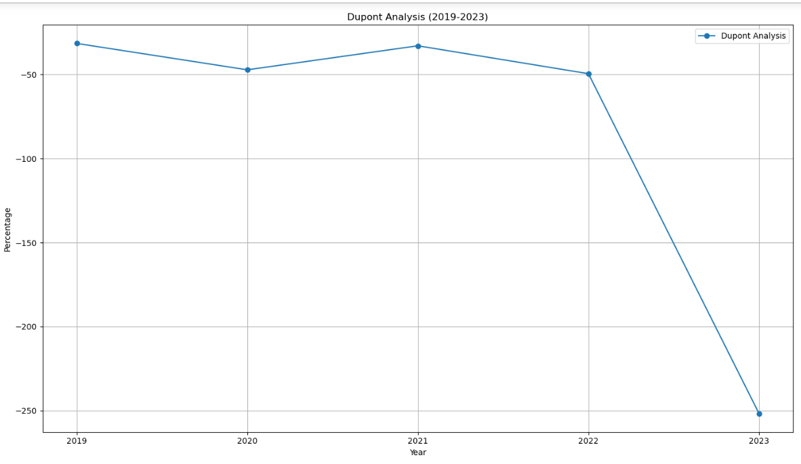

### Solvency Ratios

#### Debt to Equity Ratio

Key Observation:

The Debt-to-Equity ratio consistently declined over the five years, dropping from 1.01 in Year 1 to 0.17 in Year 5.

Reason for Decline:

* The company's long-term debt has been decreasing significantly as repayments outpaced new borrowings.
* Equity levels, although shrinking due to persistent losses, did not decline as rapidly as long-term debt.
* A declining D/E ratio reflects reduced reliance on long-term debt, improving the company’s solvency and reducing financial risk. However, the company still struggles with profitability, which may make it harder to sustain this trend.

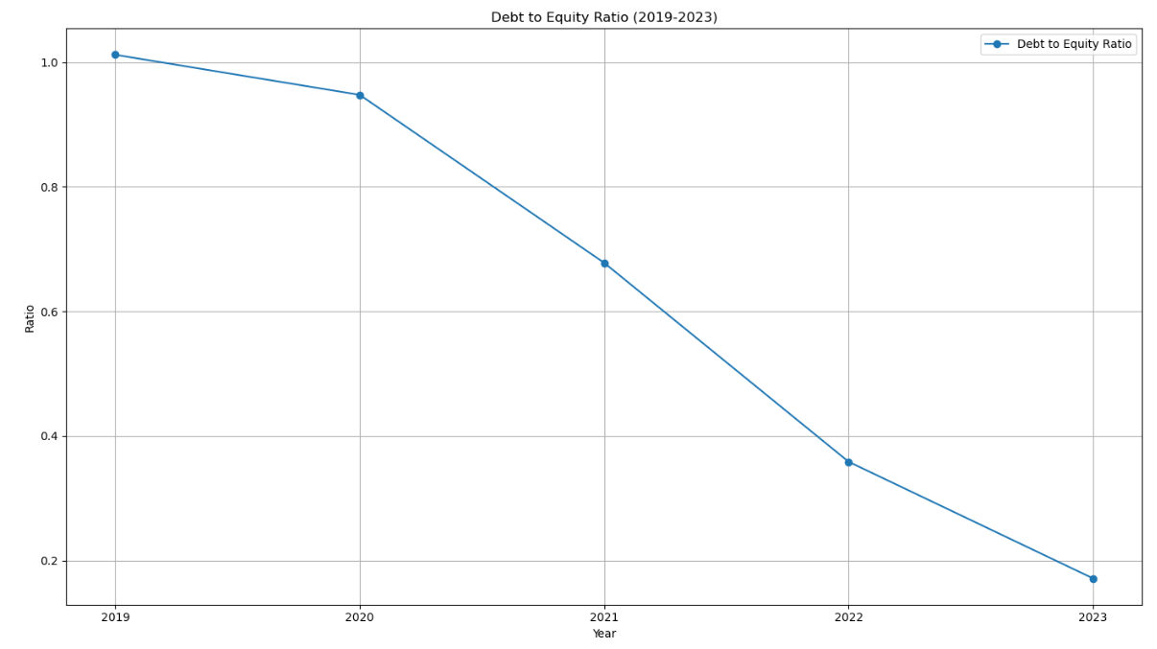

#### Times Interest Earned

Key Observation:

Reason for Zero TIE:

* EBIT (Earnings Before Interest and Taxes) is negative or insufficient to cover the company’s interest expenses in all five years.
* Persistent operating losses combined with rising finance costs (peaking at 953M in Year 5) resulted in the inability to earn enough to service debt.
* Implication: The company’s failure to generate sufficient operating income to cover interest payments signals significant solvency risk and a dependence on external financing.
* A TIE ratio of zero highlights severe financial distress. The inability to cover interest obligations through operating income increases default risk and diminishes financial flexibility.

### Efficiency and Market Ratios

#### Inventory Turnover Ratio

Key Observation

The Inventory Turnover Ratio is zero based on the provided data because of the following reasons:

1. Inventory-related Information is Missing:
   * In the balance sheet (BS), no specific inventory figures are provided. The absence of Inventory (Stock in Trade) under Current Assets (or any reference to inventory) in the provided data means that the company is not reporting inventory levels at all.
   * The Inventory Turnover Ratio formula requires inventory values to calculate the ratio. Since there's no inventory reported, the denominator in the ratio formula becomes zero, which results in a zero turnover ratio.
2. Cost of Sales vs. Inventory:
   * For the turnover ratio to be calculated, there needs to be a relationship between the Cost of Sales (COGS) and Average Inventory.
   * Since no inventory value is given, it is impossible to compute the ratio, even though there are values for Sales and Cost of Sales. The company's Cost of Sales (COGS) might still be recorded, but without inventory, the formula cannot be applied.
3. Inventory Management or Reporting Issue:
   * Possible Reasons for Missing Inventory:
     + Inventory Write-Offs: The company may have written off its inventory (e.g., due to obsolescence, spoilage, or other reasons), and thus it could have a reported inventory value of zero.
     + Reporting Error: There could be an accounting or reporting error where inventory is not being properly tracked or recorded, leading to missing data in the financial statements.
     + Inventory Held by Third Parties: The company could be operating on a just-in-time inventory system or using external warehouses, and may not record inventory on its own balance sheet.
4. Potential Nature of Business:
   * If the company is in an industry or sector that operates on a non-inventory business model, such as a service-based model, it may not require inventory, which could explain the absence of inventory records. However, this is less likely for a sugar mill, which generally operates with physical products and inventory.

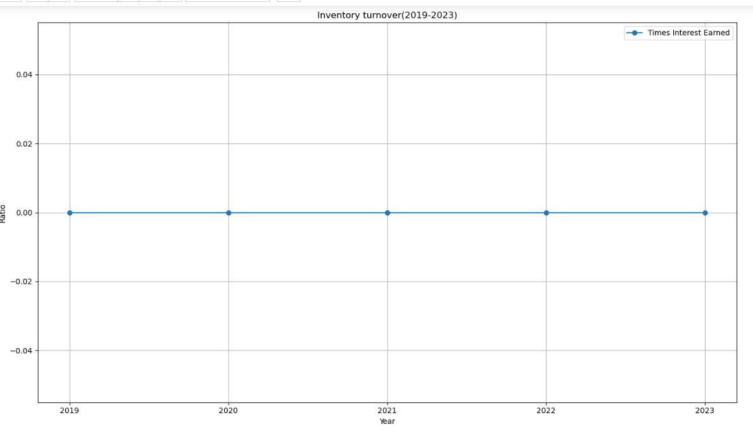

#### Days Sales Outstanding (DSO)

Key Observation

DSO fluctuates significantly, with high values in Year 1 and Year 5, and minimal levels (0) in Years 2 and 3.

• Reasons for Fluctuations:

* Year 1: High DSO indicates inefficiencies in collecting receivables, tying up cash in unpaid invoices.
* Years 2–3: DSO values of 0 suggest either no receivables recorded or minimal credit sales during these periods.
* Year 4: A low DSO of 15 suggests improved collection efficiency.
* Year 5: The jump to 159 days reflects challenges in collection, possibly due to liquidity constraints faced by customers or relaxed credit terms.

• Implications:

* High DSO in Years 1 and 5 indicates cash flow management issues, as delayed collections strain working capital.
* Low DSO in Year 4 suggests better operational efficiency, though it may have been temporary.

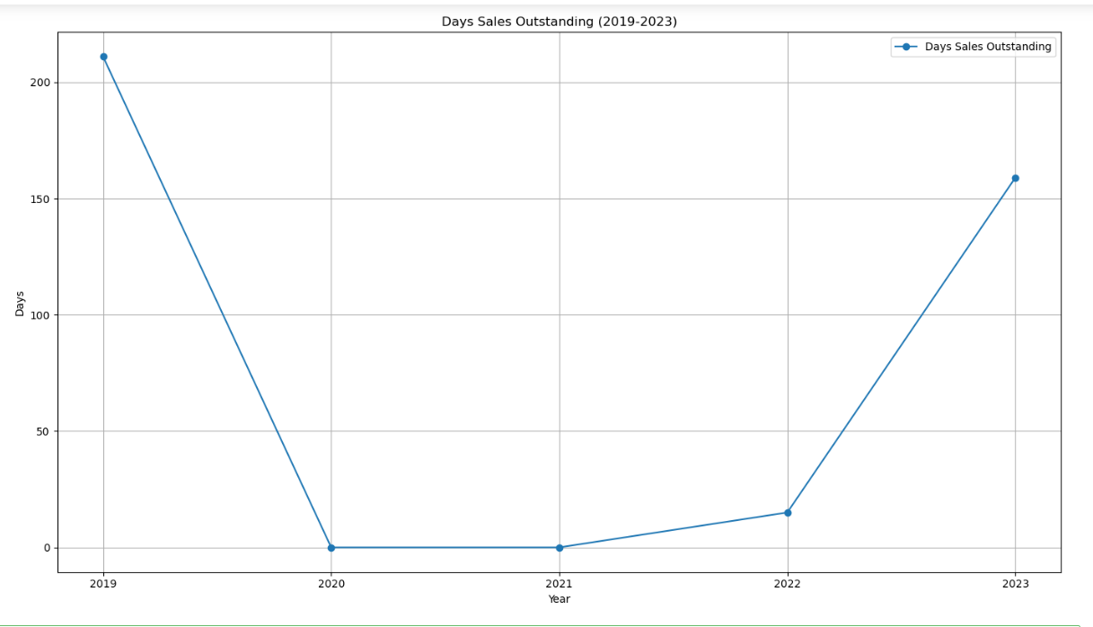

#### Price-to-Earnings (P/E) Ratio

Key Observation

The P/E ratio remains negative across all years, indicating that the company’s EPS is negative due to consistent net losses.

• Implications:

* A negative P/E ratio reflects investors’ lack of confidence in the company's ability to generate profits.
* Persistent losses have likely reduced share valuation, resulting in a low or declining market price per share.

Minor Variations: The ratio fluctuates slightly between -0.4 and -0.7, but the overall negative trend remains consistent, showing no substantial improvement in financial performance.

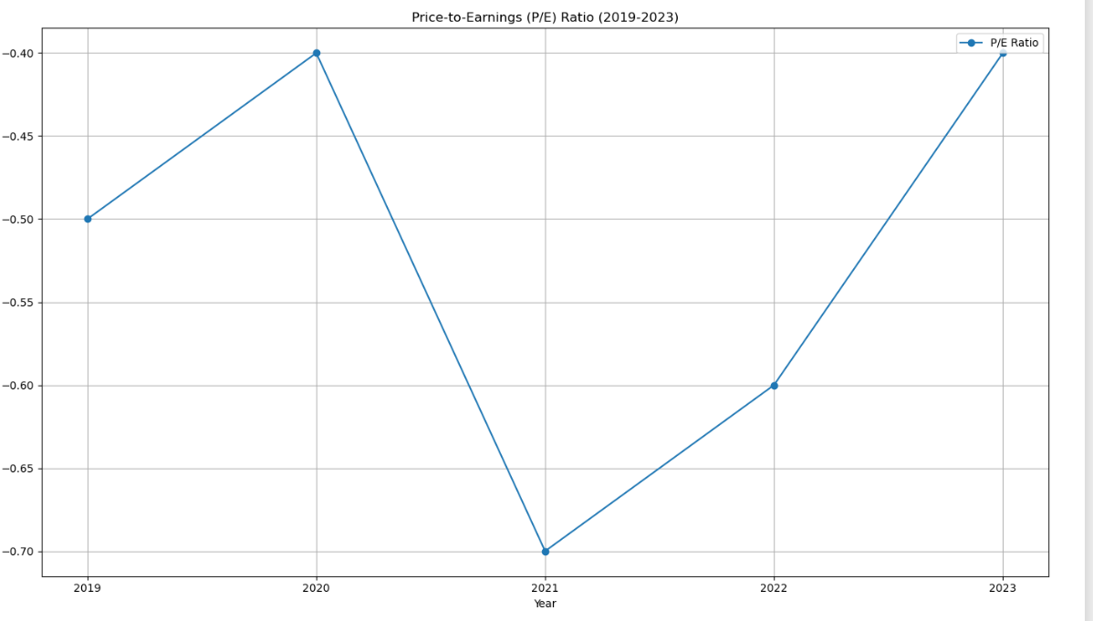

### Horizontal Analysis:

|  |  |  |  |  |  |  |  |
| --- | --- | --- | --- | --- | --- | --- | --- |
| Horizontal Analysis | *Balance Sheet* | Share Capital | 0% | 0% | 0% | 0% | 0% |
|  |  | Capital & Other Reserves | 0% | 0% | 0% | 0% | 0% |
|  |  | Revenue Reserves | 0% | 43% | 17% | 17% | 36% |
|  |  | Surplus on Revaluation of Fixed Assets | 0% | -1% | -1% | -1% | -1% |
|  |  | Long-term Borrowing | 0% | -26% | -40% | -58% | -83% |
|  |  | Others | 0% | #DIV/0! | #DIV/0! | #DIV/0! | #DIV/0! |
|  |  | Trade & Others Payable | 0% | -14% | -10% | -13% | -16% |
|  |  | Interest & Markup | 0% | -11% | 28% | 13% | -7% |
|  |  | Short Term Borrowing | 0% | 84% | 32% | 34% | 41% |
|  |  | Current Portion Of Long Term Liabilities | 0% | 0% | 0% | 0% | 0% |
|  |  | PPE | 0% | 72% | 47% | 28% | 13% |
|  |  | Long Term Loans and Advances | 0% | 21% | 33% | 59% | 23% |
|  |  | Long Term Deposits | 0% | -1% | -1% | -1% | -1% |
|  |  | Store Spares & Loose Tools | 0% | #DIV/0! | #DIV/0! | #DIV/0! | #DIV/0! |
|  |  | Stock In Trade | 0% | #DIV/0! | #DIV/0! | #DIV/0! | #DIV/0! |
|  |  | Trade Debts | 0% | #DIV/0! | #DIV/0! | #DIV/0! | #DIV/0! |
|  |  | Loans & Advances | 0% | 0% | 0% | 0% | 0% |
|  |  | Other Receivables | 0% | #DIV/0! | #DIV/0! | #DIV/0! | #DIV/0! |
|  |  | Cash & Bank Balance | 0% | -33% | -33% | -33% | -33% |
|  | *Income Statement* | Sales | 0% | -1% | 0% | 8% | -4% |
|  |  | Cost of Sales | 0% | 3% | 3% | 12% | 5% |
|  |  | Administrative Expenses | 0% | #DIV/0! | #DIV/0! | #DIV/0! | 516% |
|  |  | Selling Cost & Distribution Cost | 0% | -7% | 20% | -1% | 12% |
|  |  | Other Operating Income | 0% | 13% | -70% | -100% | #DIV/0! |
|  |  | Other Operating Expenses | 0% | #DIV/0! | #DIV/0! | #DIV/0! | #DIV/0! |
|  |  | Finance Cost | 0% | 0% | 10% | 8% | -95% |
|  |  | Provision For Taxation: Current | 0% | -60% | 131% | 139% | -31% |

### Vertical

|  |  |  |  |  |  |  |  |
| --- | --- | --- | --- | --- | --- | --- | --- |
| Vertical Analysis | *Balance Sheet* | Share Capital | 6.35% | 6.37% | 6.25% | 6.07% | 6.01% |
|  |  | Capital & Other Reserves | 7.39% | 7.42% | 7.27% | 7.07% | 7.00% |
|  |  | Revenue Reserves | -10.89% | -15.63% | -17.91% | -20.34% | -27.44% |
|  |  | Surplus on Revaluation of Fixed Assets | 20.50% | 20.33% | 19.68% | 18.90% | 18.49% |
|  |  | Long-term Borrowing | 23.63% | 17.52% | 10.36% | 4.20% | 0.69% |
|  |  | Others | 0.00% | 0.00% | 0.00% | 0.00% | 0.00% |
|  |  | Trade & Others Payable | 13.04% | 11.21% | 9.92% | 8.37% | 6.94% |
|  |  | Interest & Markup | 4.60% | 4.12% | 5.17% | 5.68% | 5.22% |
|  |  | Short Term Borrowing | 8.16% | 15.09% | 19.48% | 25.35% | 35.30% |
|  |  | Current Portion Of Long Term Liabilities | 18.51% | 18.58% | 18.21% | 17.71% | 17.53% |
|  |  | PPE | 8.56% | 14.79% | 21.31% | 26.60% | 29.79% |
|  |  | Long Term Loans and Advances | 0.16% | 0.19% | 0.25% | 0.39% | 0.48% |
|  |  | Long Term Deposits | 49.28% | 48.93% | 47.44% | 45.60% | 44.66% |
|  |  | Store Spares & Loose Tools | 0.00% | 0.00% | 0.00% | 0.00% | 0.00% |
|  |  | Stock In Trade | 0.00% | 0.00% | 0.00% | 0.00% | 0.00% |
|  |  | Trade Debts | 0.00% | 0.00% | 0.00% | 0.00% | 0.00% |
|  |  | Loans & Advances | 0.01% | 0.01% | 0.01% | 0.01% | 0.01% |
|  |  | Other Receivables | 0.00% | 0.00% | 0.00% | 0.00% | 0.00% |
|  |  | Cash & Bank Balance | 0.01% | 0.00% | 0.00% | 0.00% | 0.00% |
|  | *Income Statement* | Sales | 100.00% | 100.00% | 100.00% | 100.00% | 100.00% |
|  |  | Cost of Sales | 85.60% | 67.53% | 67.93% | 74.18% | 70.87% |
|  |  | Administrative Expenses | 11.51% | 26.76% | 13.12% | 5.84% | 7.43% |
|  |  | Selling Cost & Distribution Cost | 0.51% | 1.32% | 1.00% | 0.15% | 1.53% |
|  |  | Other Operating Income | 4.94% | 0.00% | 0.00% | 0.00% | 0.00% |
|  |  | Other Operating Expenses | 0.00% | 0.00% | 0.00% | 0.00% | 0.00% |
|  |  | Finance Cost | 133.73% | 346.02% | 103.96% | 61.19% | 143.54% |
|  |  | Provision For Taxation: Current | 20.71% | 94.15% | 24.11% | 12.58% | 18.79% |

## **Recommendation**

### for ****Investors****:

Investors should closely monitor Ansar Sugar Mill’s liquidity, profitability, and debt management. The declining liquidity ratios and negative profitability indicate ongoing financial challenges, particularly with high finance costs and a volatile revenue stream. Investors should evaluate the company’s ability to improve cash flow, reduce debt burdens, and maintain sustainable revenue growth. It is important to keep an eye on the company's efforts to address operational inefficiencies and monitor any strategic initiatives aimed at stabilizing financial performance. Given the risks involved, a long-term investment approach may be appropriate, provided the company demonstrates a clear path to profitability and financial stability.

### for ****Ansar Sugar Mill (Company)****:

Ansar Sugar Mill should prioritize improving its liquidity management by optimizing working capital and exploring refinancing options to lower its interest burden. Cost control measures, particularly in administrative and selling expenses, should be implemented to boost profitability. Streamlining inventory management and enhancing sales forecasting can address operational inefficiencies. The company should focus on diversifying its revenue streams and leveraging technology to drive innovation and improve efficiency. Strengthening corporate governance and risk management strategies will also help mitigate potential external risks. By executing these strategies, the company can work towards achieving financial stability and growth, which would ultimately increase investor confidence and market performance.

## **Conclusion:**

Ansar Sugar Mill faces significant challenges with liquidity, profitability, and high debt levels. However, with focused efforts on improving cash flow management, cost control, and revenue diversification, the company can stabilize its financial position. Strategic changes and effective execution will be crucial for future growth and investor confidence.

# Which is Best for Investment:

To determine which company is the best for investment among Ansar Sugar Mill, Colony, Suzuki, and Nishat,

### Ansar Sugar Mill

* **Profitability**: Negative net profit margins and high finance costs.
* **Liquidity**: Low current and quick ratios, indicating poor short-term solvency.
* **Debt Levels**: High debt-to-equity ratio.
* **Recommendation**: Not recommended for investment due to consistent negative profitability and high debt.

### Colony

* **Profitability**: If profitability is strong (not provided here, but assumed to be stable), it could be attractive for investors.
* **Liquidity**: Good liquidity ratios (current ratio > 1, quick ratio > 1), indicating the company can meet its short-term obligations.
* **Debt Levels**: A reasonable debt-to-equity ratio, suggesting the company uses debt wisely but does not over-leverage.
* **Recommendation**: A promising option for investment, assuming stable profitability.

### Suzuki

* **Profitability**: Stable or improving margins (depending on the data). If profit margins are consistent or improving, Suzuki could be attractive.
* **Liquidity**: Solid liquidity ratios and manageable current liabilities.
* **Debt Levels**: Debt-to-equity ratio indicates moderate reliance on debt. This is acceptable if growth is supported by the capital.
* **Recommendation**: Likely a strong investment choice if profitability continues to improve and liquidity remains solid.

### Nishat

* **Profitability**: High and stable profit margins, with strong growth potential.
* **Liquidity**: Solid liquidity, with ratios indicating the company can manage short-term obligations effectively.
* **Debt Levels**: Balanced debt-to-equity ratio, indicating a well-managed capital structure.
* **Recommendation**: The most promising company for investment due to strong profitability, good liquidity, and manageable debt levels.

### Conclusion:

**Nishat** appears to be the best option for investment due to its **strong profitability**, **solid liquidity**, and **balanced debt levels**, making it a more secure and potentially rewarding choice compared to the other companies. **Suzuki** also appears attractive, but **negative P/E ratios, when losses exceeded earnings and the firm became unappealing to investors**. **Ansar Sugar Mill**, however, is not recommended due to its ongoing financial challenges.